**VISVESVARAYA TECHNOLOGICAL UNIVERSITY**

**“JnanaSangama”, Belgaum -590014, Karnataka.**



LAB REPORT

on

COMPUTER NETWORKS

***Submitted by***

Rachit Mehta (1BM21CS156)

***in partial fulfillment for the award of the degree of***

**BACHELOR OF ENGINEERING**

***in***

COMPUTER SCIENCE AND ENGINEERING



B.M.S. COLLEGE OF ENGINEERING

**(Autonomous Institution under VTU)**

BENGALURU-560019

June-2023 to September-2023

B. M. S. College of Engineering,

**Bull Temple Road, Bangalore 560019**

(Affiliated To Visvesvaraya Technological University, Belgaum)

**Department of Computer Science and Engineering**



**CERTIFICATE**

This is to certify that the Lab work entitled “**Computer Networks**” carried out by

**Rachit Mehta (1BM21CS156),** who is bonafide student of **B.M.S. College of Engineering.** It is in partial fulfillment for the award of **Bachelor of Engineering in Computer Science and Engineering** of the Visvesvaraya Technological University, Belgaum during the academic semester June-2023 to September-2023. The Lab report has been approved as it satisfies the academic requirements in respect of a **Computer Networks (22CS4PCCON)** work prescribed for the said degree.

Name of the Lab-In charge: Dr. Jyothi S Nayak

Nandini Vineeth Professorand Head

Department of CSE Department of CSE

BMSCE, Bengaluru BMSCE, Bengaluru

**Index Sheet**

|  |  |  |
| --- | --- | --- |
| **Lab**  **Program No.** | **Program Details** | **Page No.** |
|  | **CYCLE 1** |  |
| 1 | Create a topology and simulate sending a simple PDU from source to destination using hub and switch as connecting devices and demonstrate ping message. | 4 |
| 2 | Configure IP address to routers in packet tracer. Explore the following messages: ping responses, destination unreachable, request timed out, reply | 9 |
| 3 | Default routing and Static Routing | 14 |
| 4 | DHCP within LAN and outside LAN | 17 |
| 5 | Configure RIP routing Protocol in Routers | 21 |
| 6 | Configure OSPF routing protocol | 24 |
| 7 | Demonstrate the TTL/ Life of a Packet | 27 |
| 8 | Configure Web Server, DNS within a LAN. | 30 |
| 9 | To construct simple LAN and understand the concept and operation of Address Resolution Protocol (ARP) | 32 |
| 10 | To understand the operation of TELNET by accessing the router in server room from a PC in IT office. | 35 |
| 11 | To construct a VLAN and make the PC’s communicate among a VLAN | 38 |
| 12 | To construct a WLAN and make the nodes communicate wirelessly | 41 |
|  | **CYCLE 2** |  |

|  |  |  |
| --- | --- | --- |
| 13 | Write a program for error detecting code using CRC- CCITT (16-bits). | 44 |
| 14 | Write a program for congestion control using Leaky bucket algorithm. | 48 |
| 15 | Using TCP/IP sockets, write a client-server program to make client sending the file name and the server to send back the contents of the requested file if present. | 50 |
| 16 | Using UDP sockets, write a client-server program to make client sending the file name and the server to send back the contents of the requested file if present. | 52 |

**Course Outcome**

|  |  |
| --- | --- |
| CO1 | Apply the fundamental concepts of communication in networking. |
| CO2 | Analyze the various protocols, techniques in TCP/IP network architecture |
| CO3 | Develop programs that demonstrate the functionalities of physical, Data Link, Network,Transport or Application layer |

**PROGRAM -1**

Question : Create a topology and simulate sending a simple PDU from source to destination using hub and switch as connecting devices and demonstrate ping message.

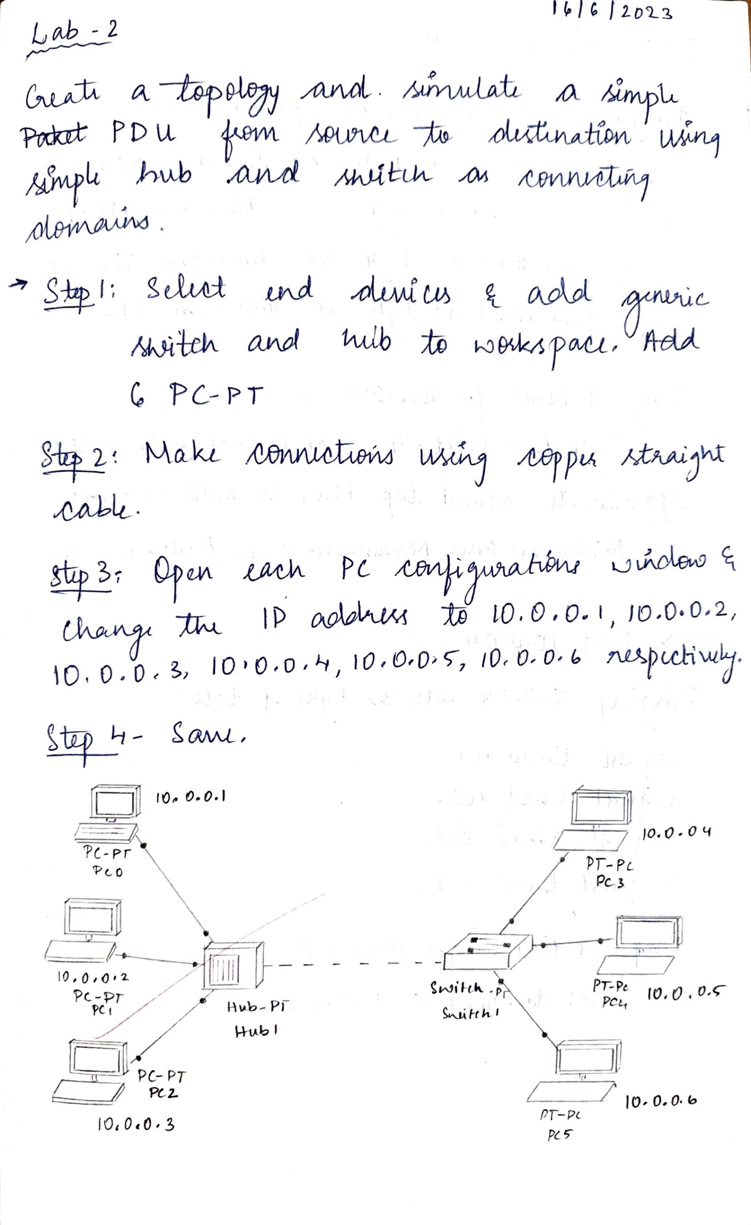

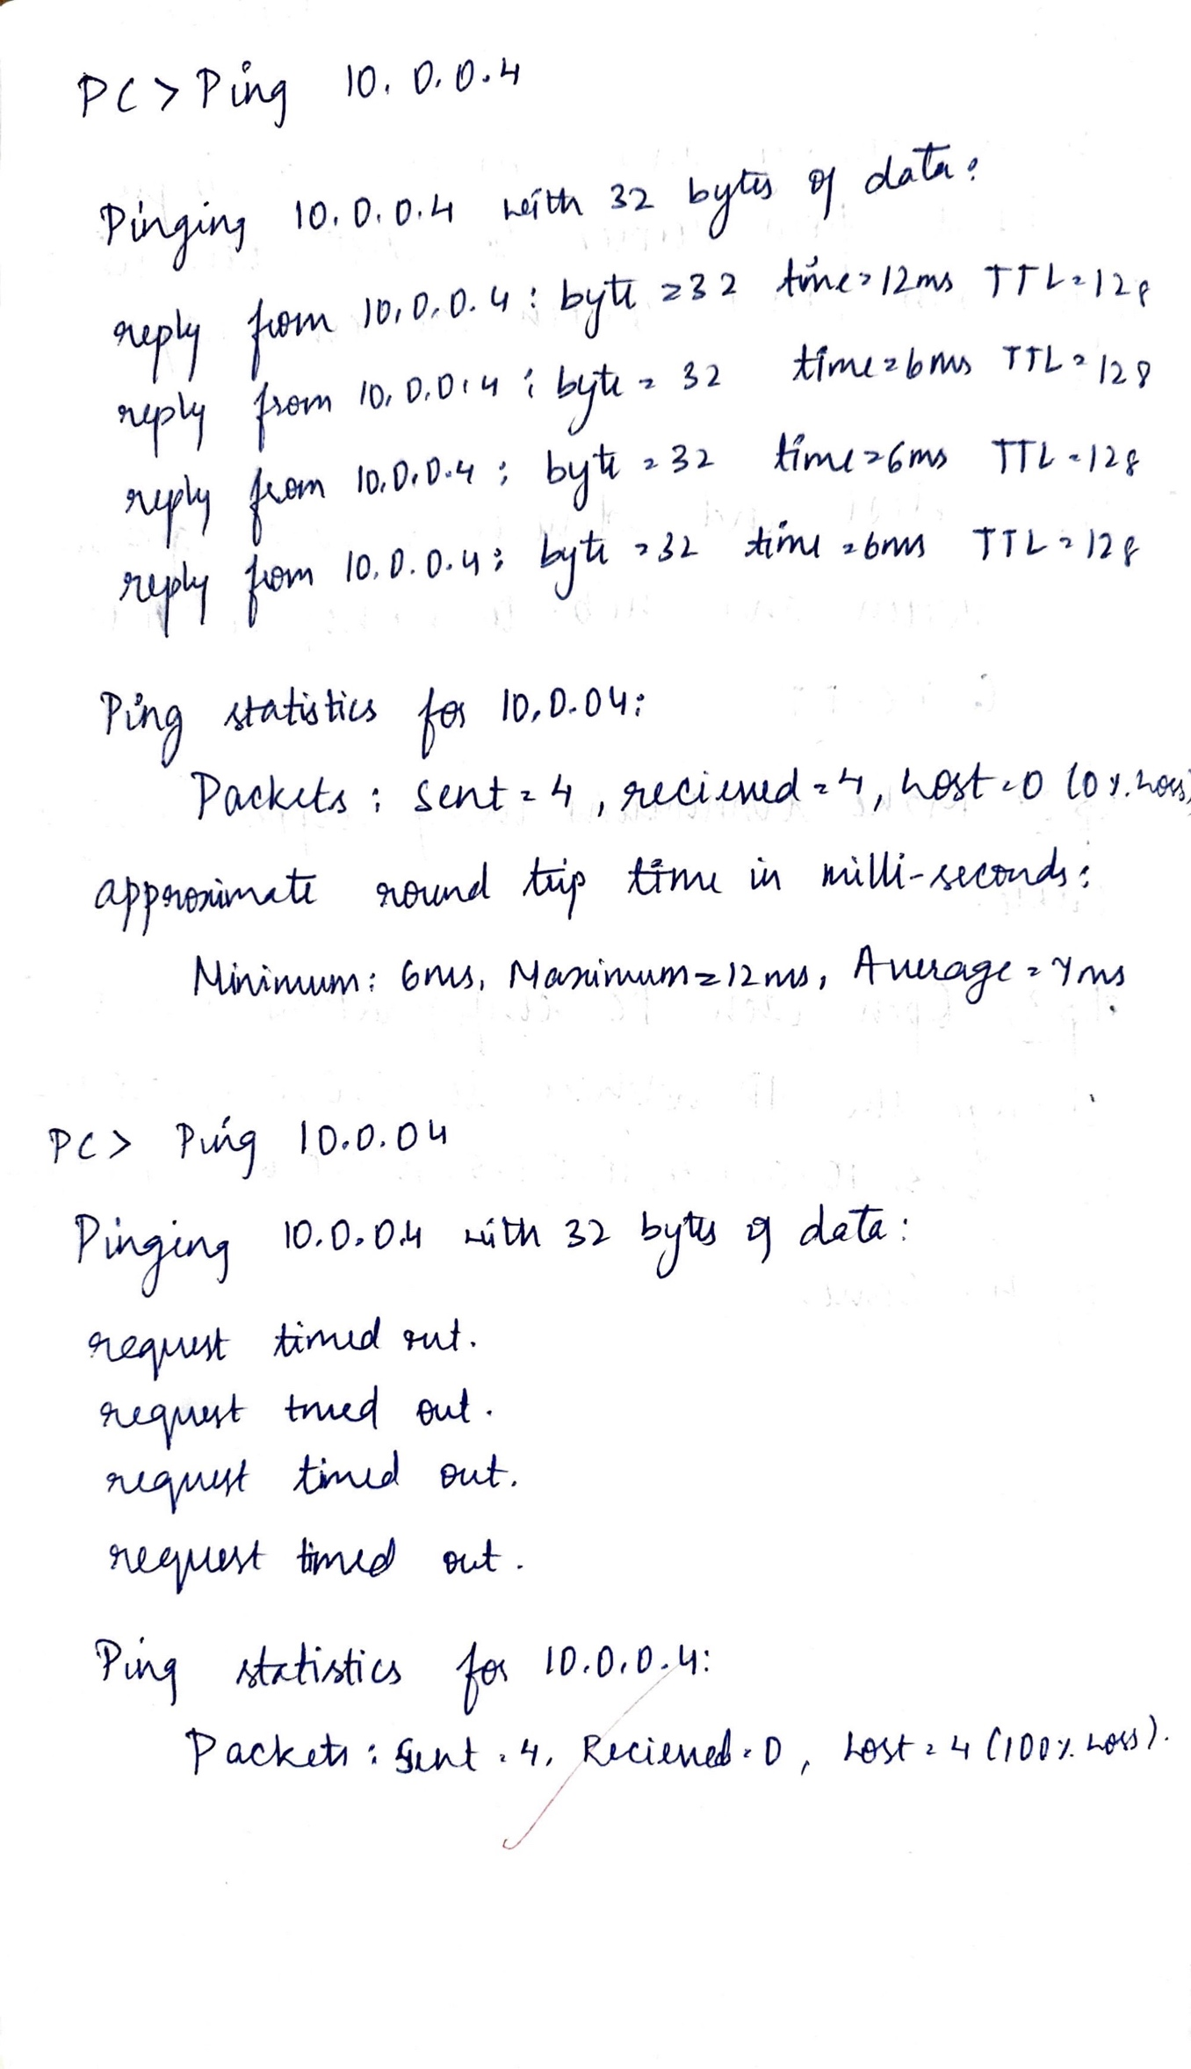

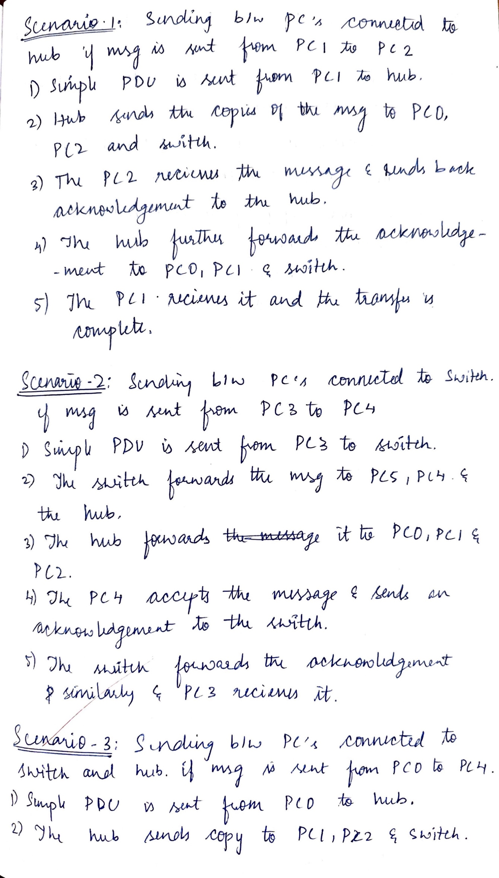

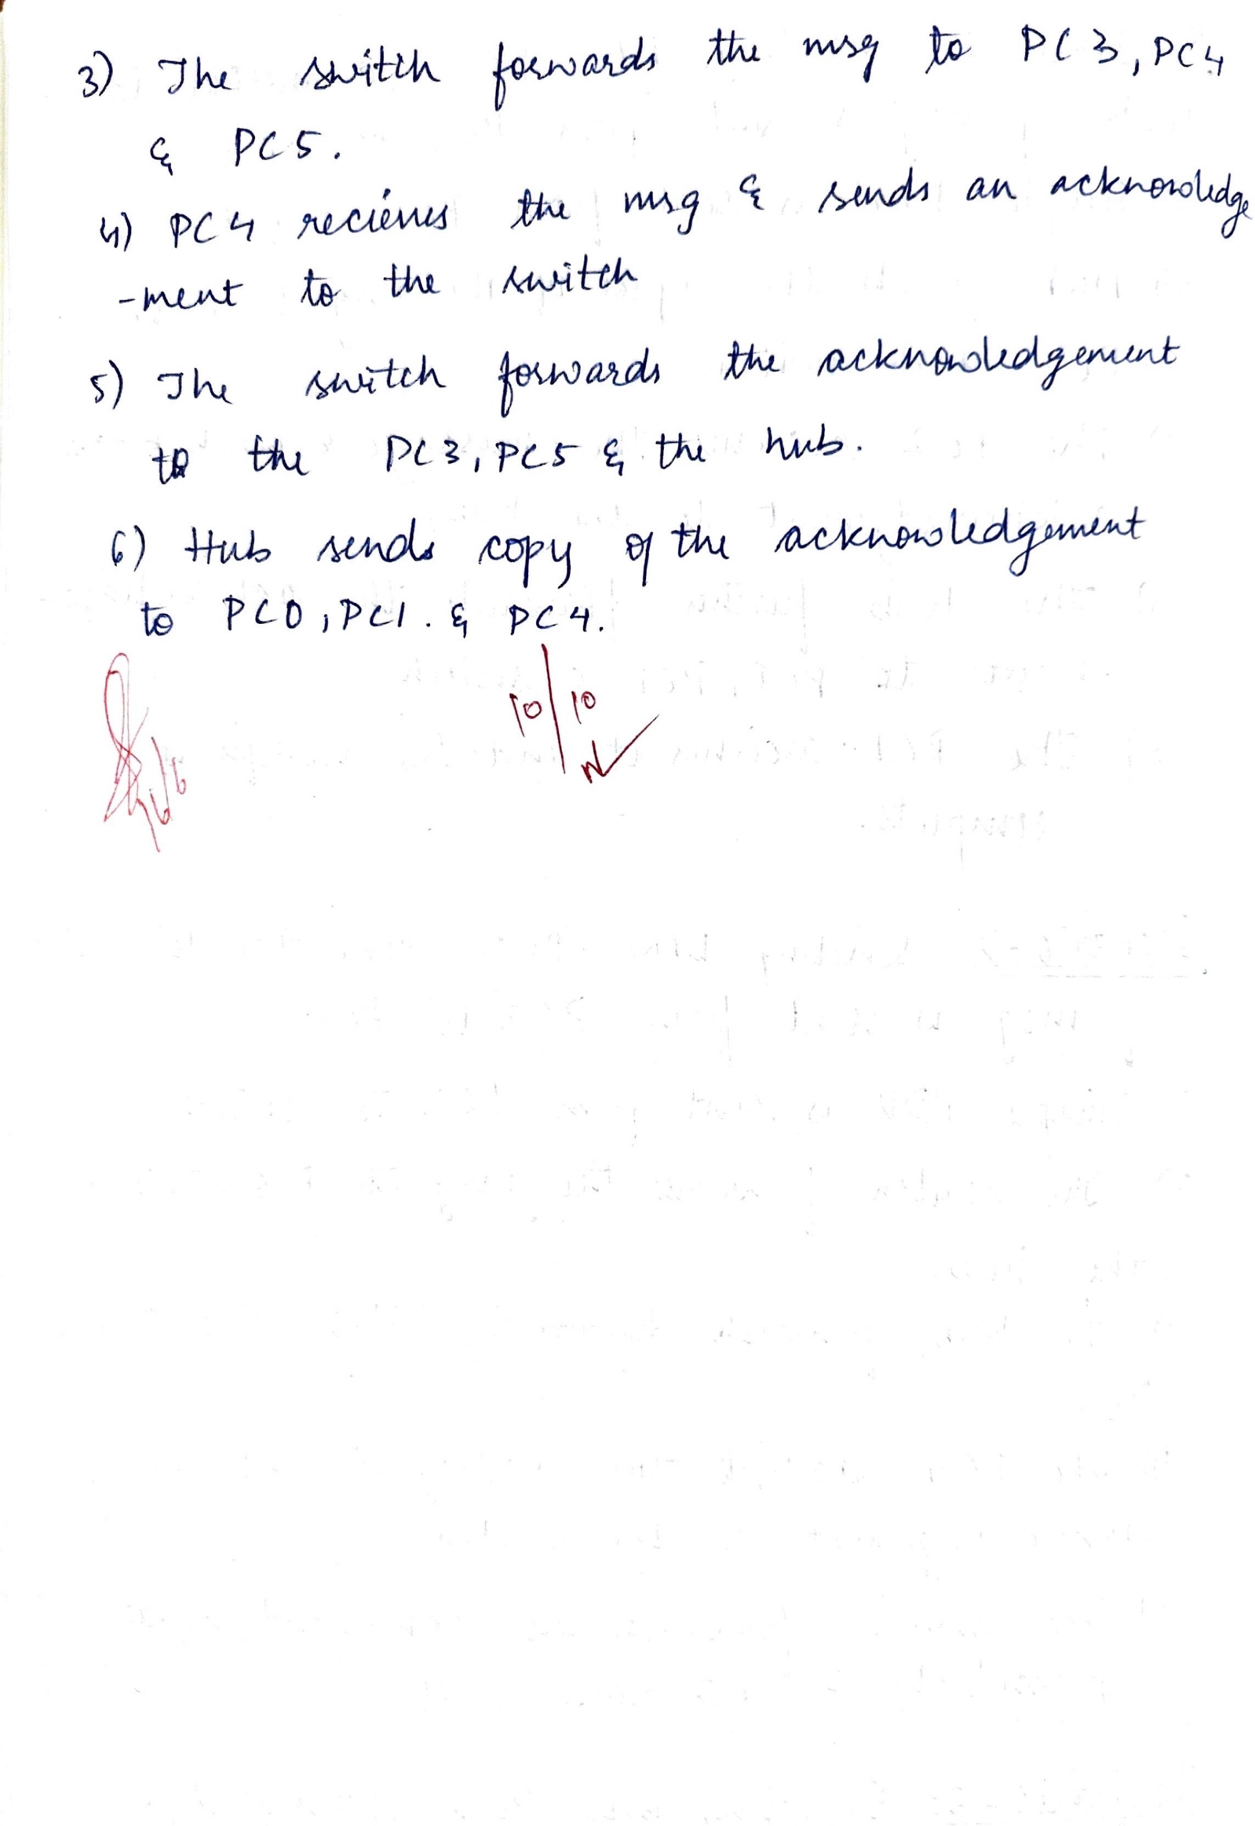

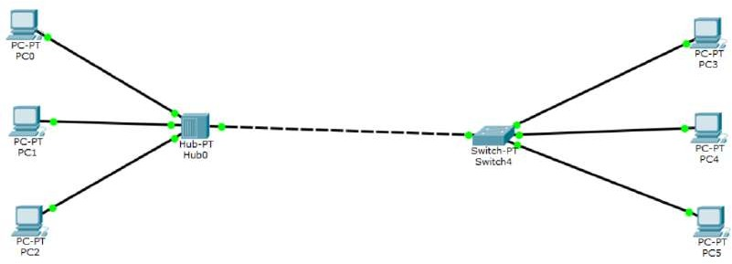

**Output:**

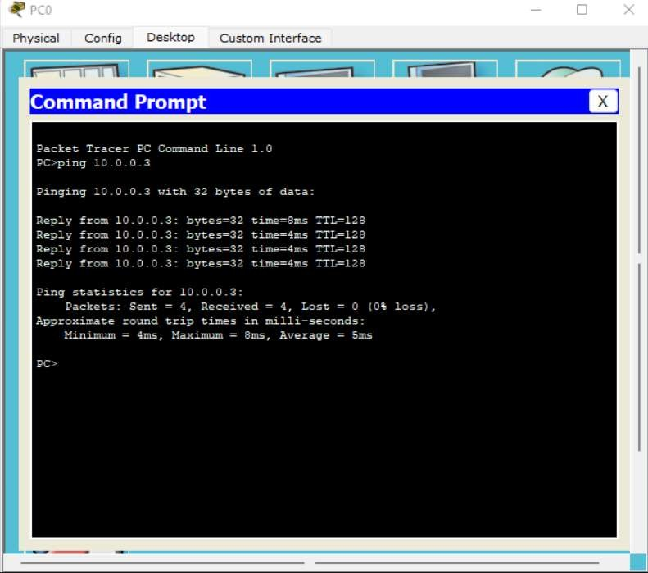

PROGRAM -2

Question : Configure IP address to routers in packet tracer. Explore the following messages: ping responses, destination unreachable, request timed out, reply

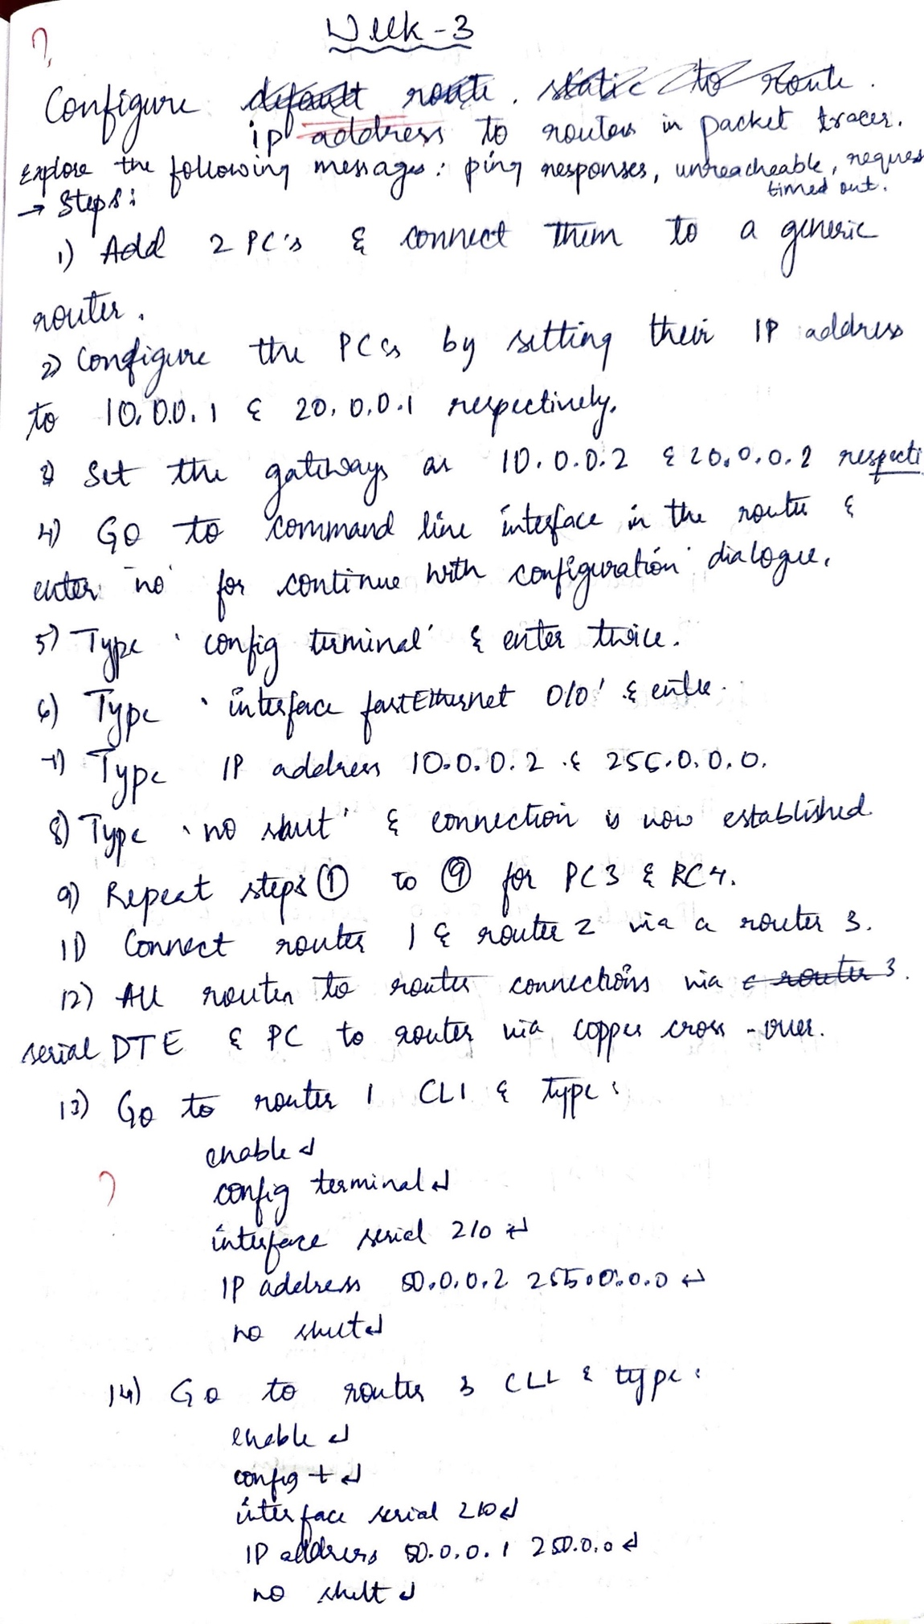

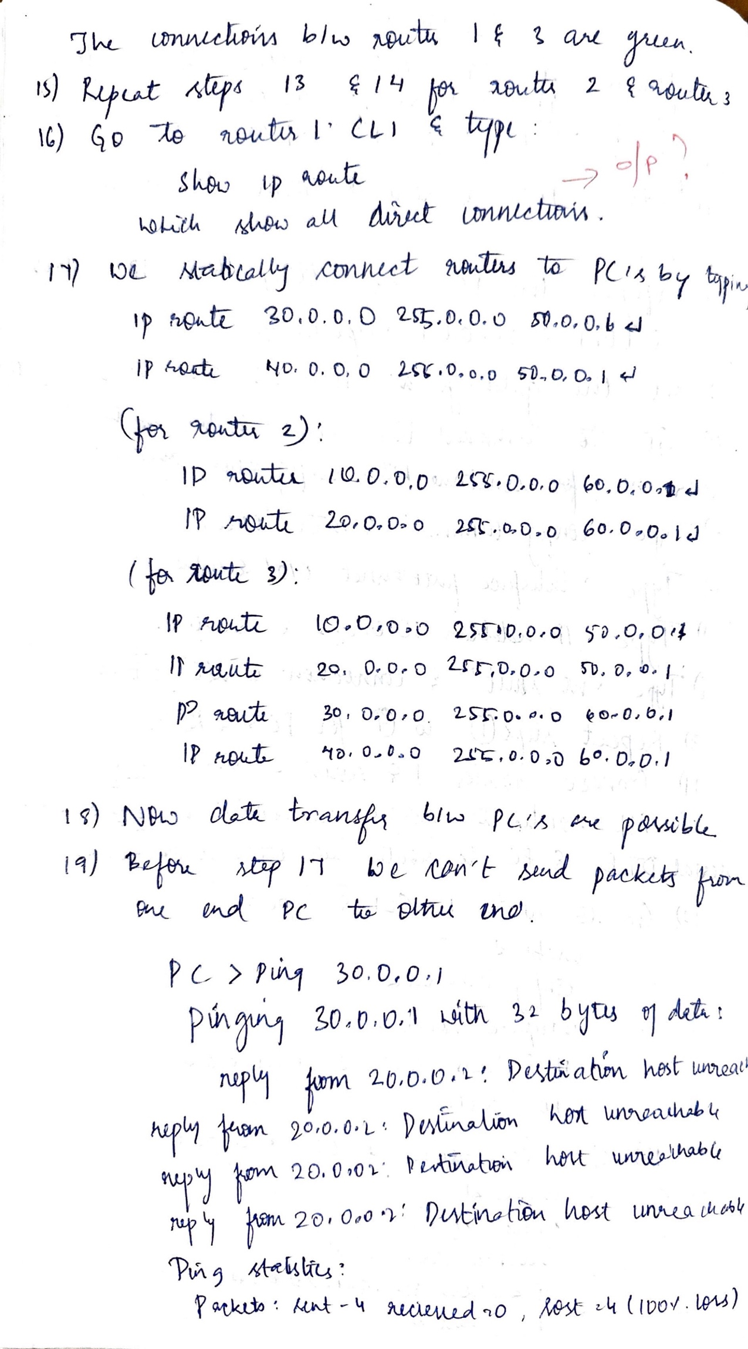

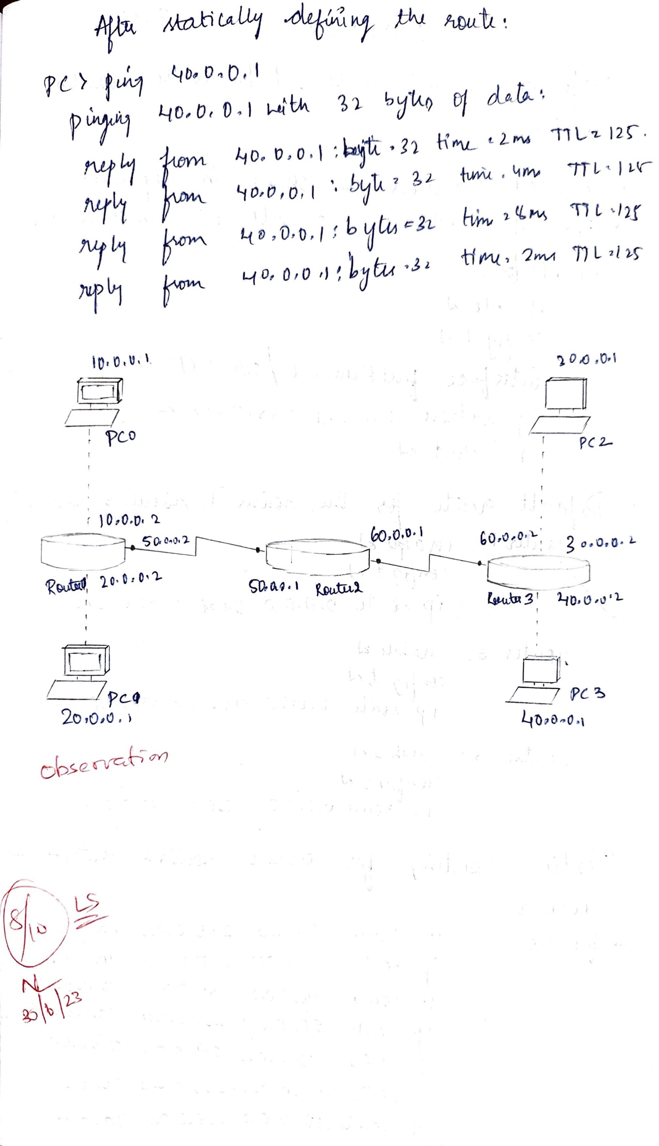

**Topology:**

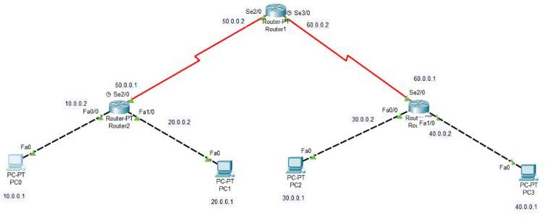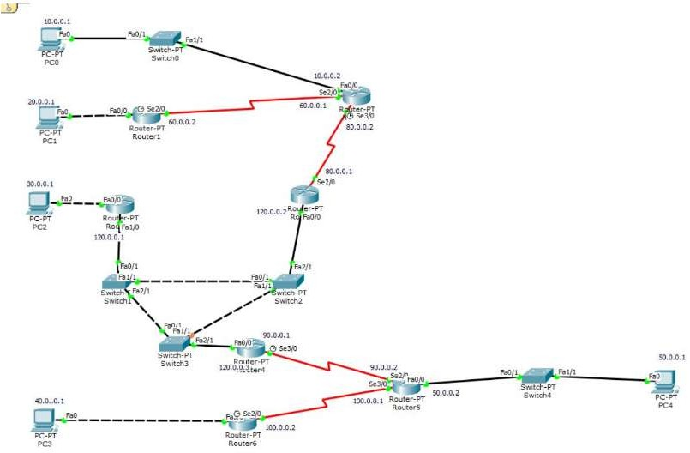

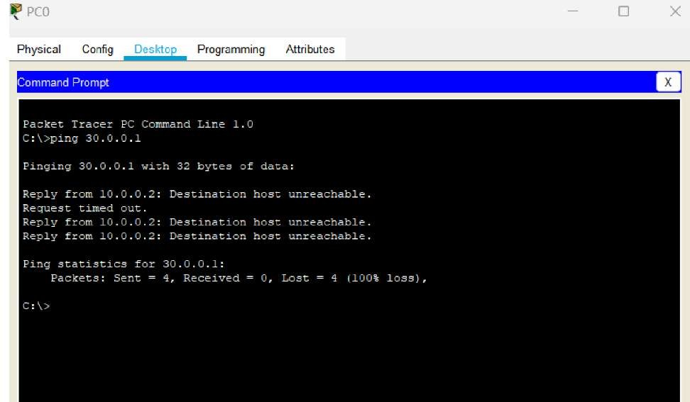**Output:**

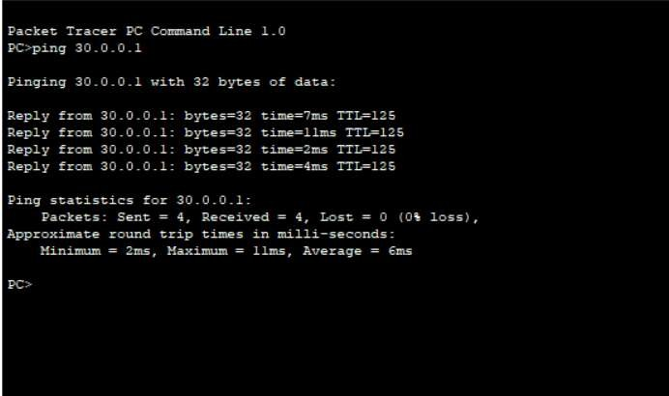

PROGRAM -3

Configure default route, static route to the Router

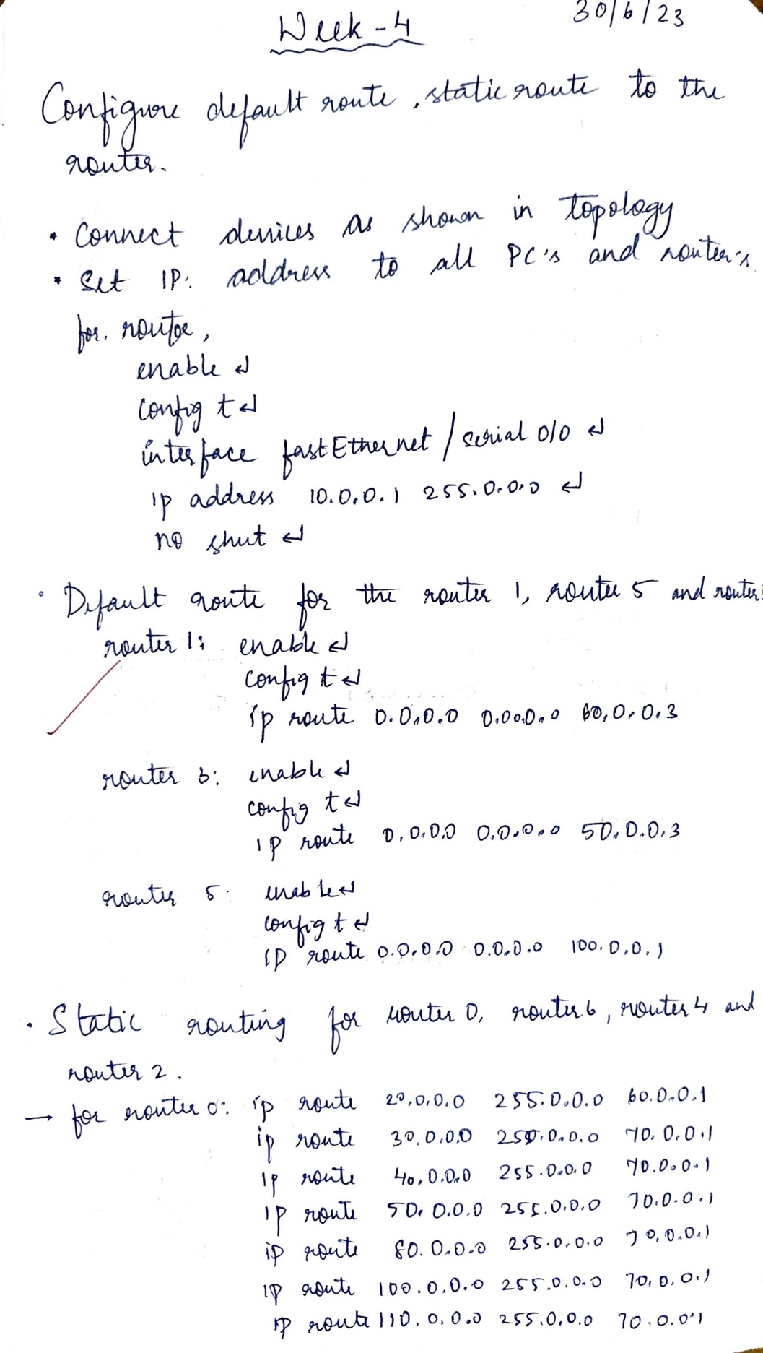

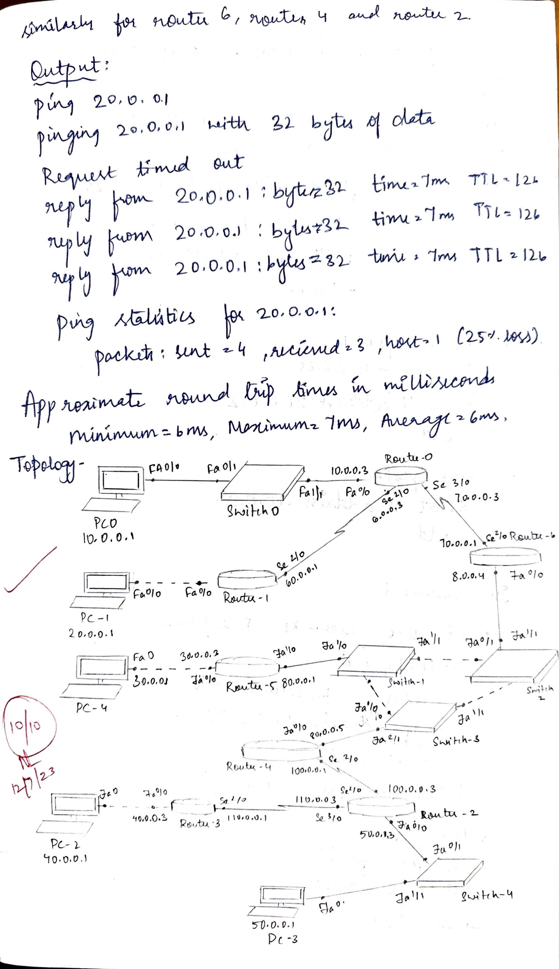

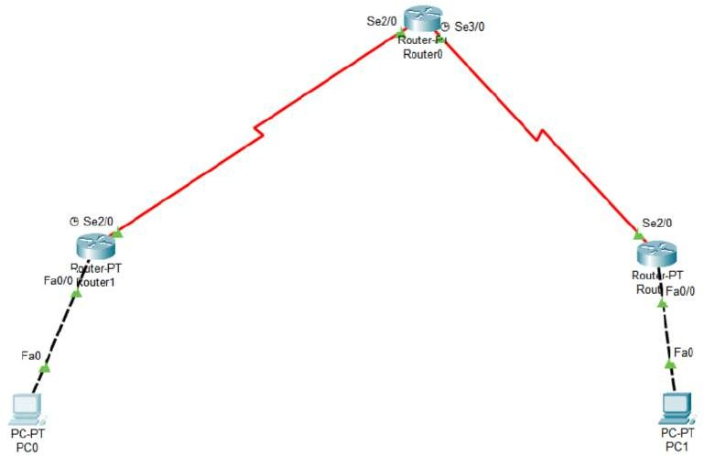**Topology:**

**Output:**

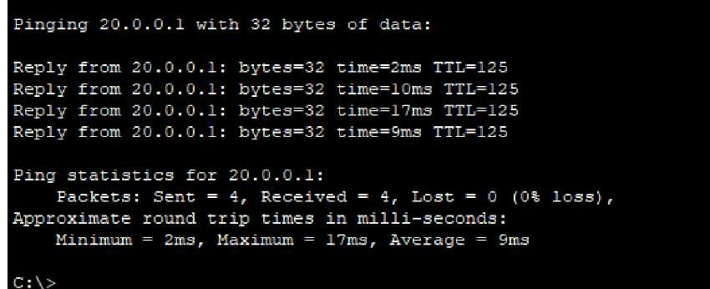

PROGRAM -4

Configure DHCP within a LAN and outside LAN

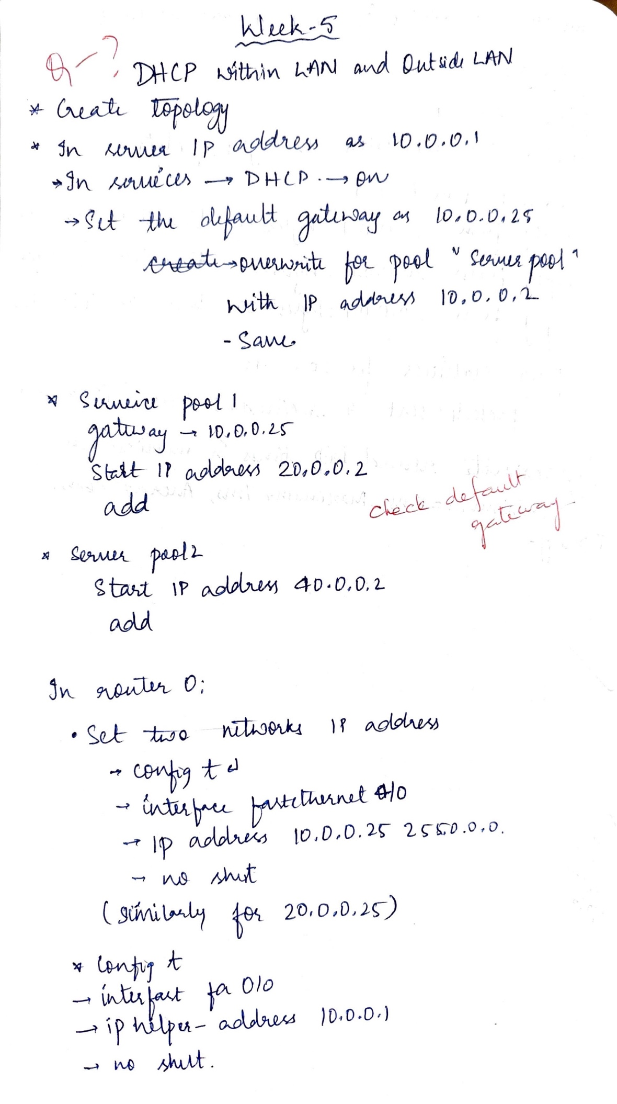

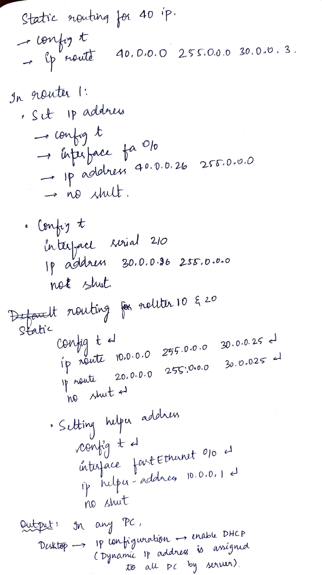

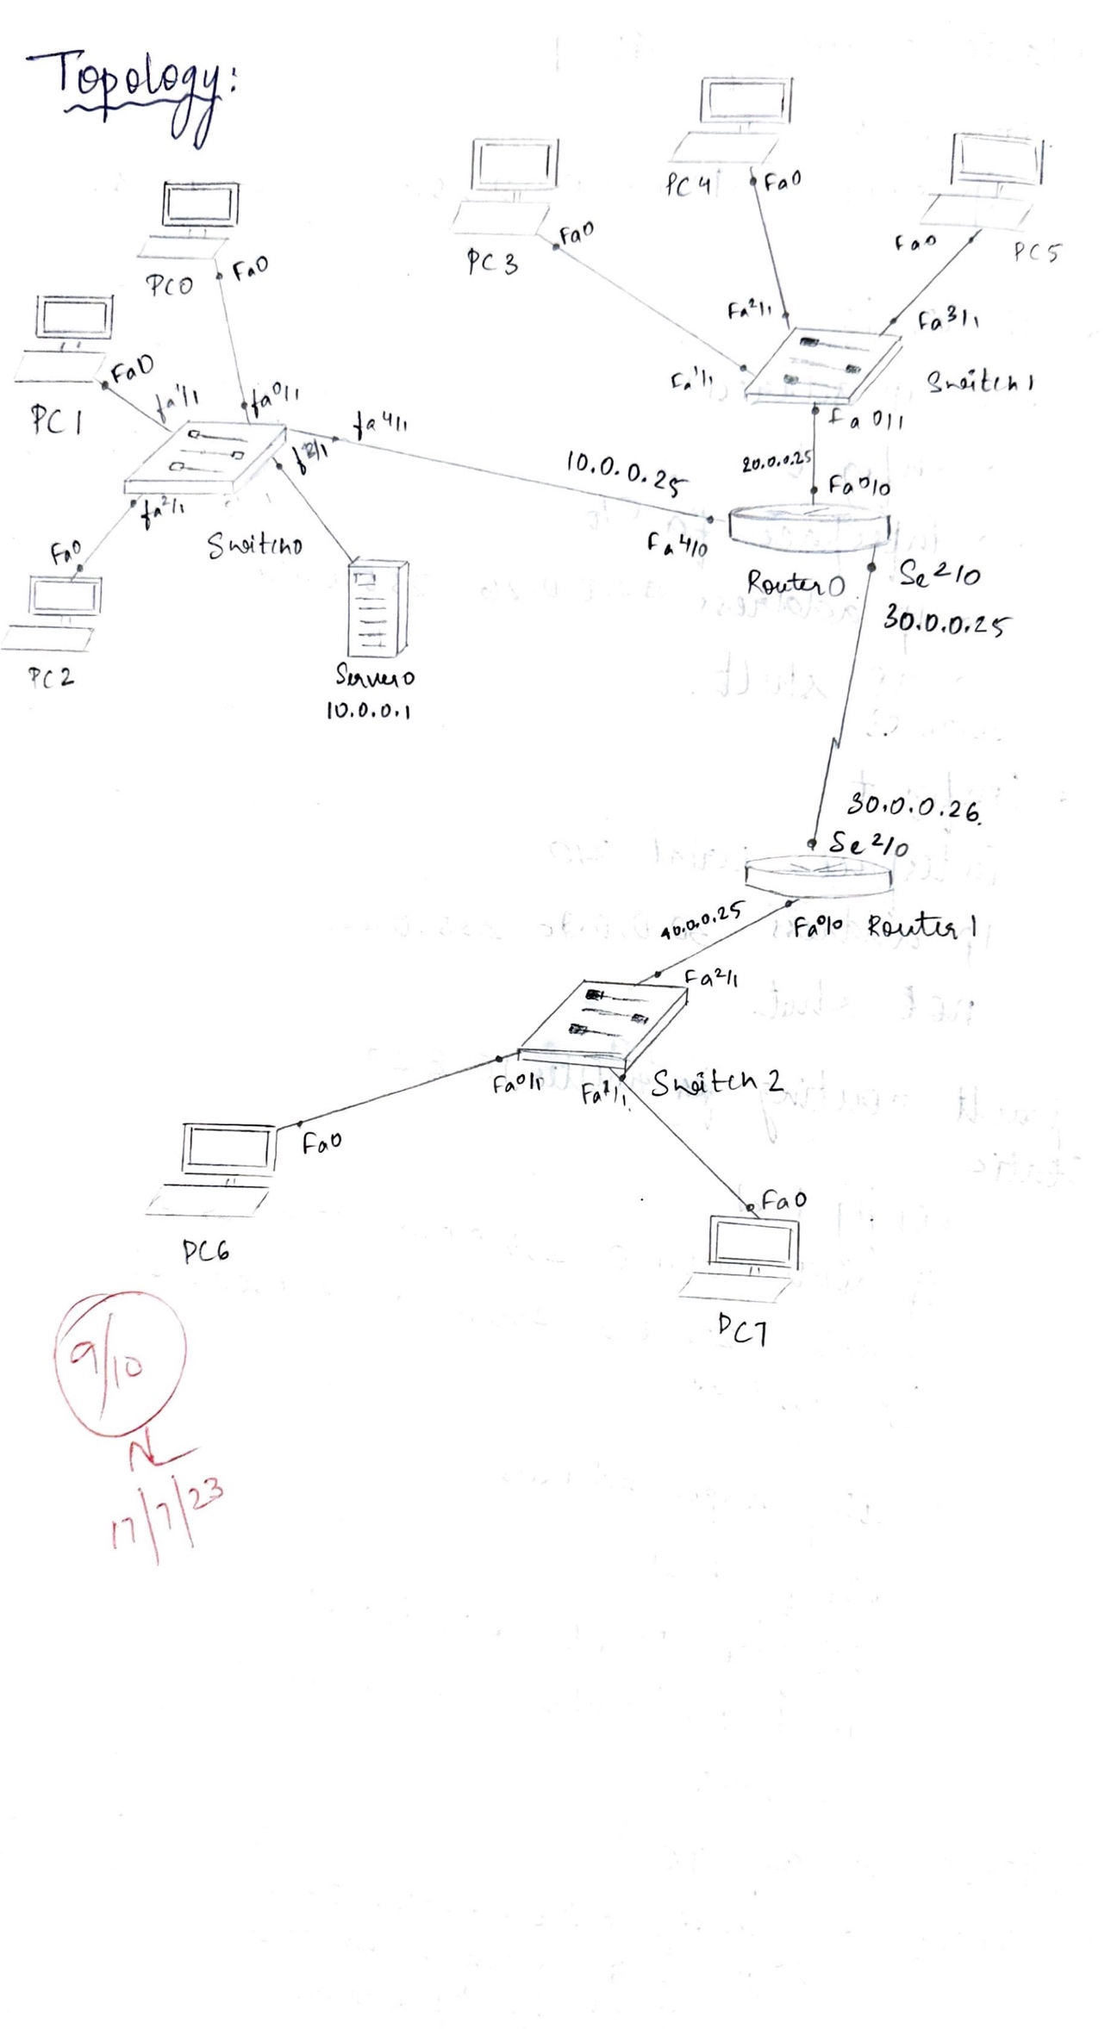

**Topology:**

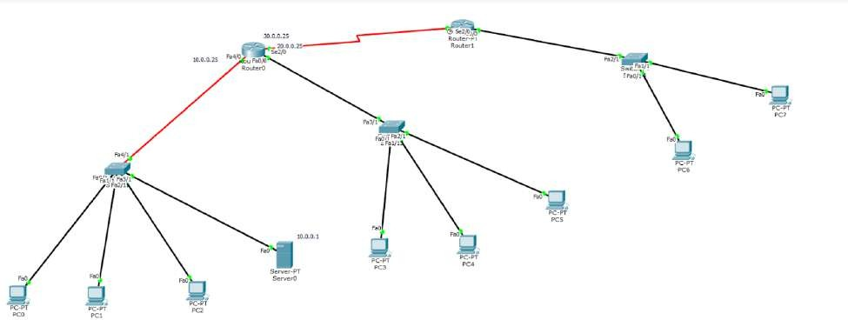

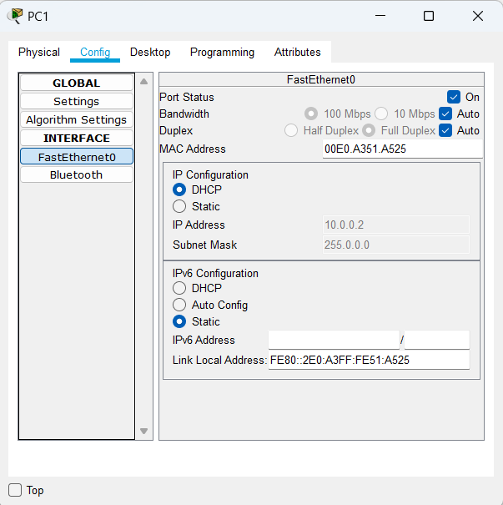**Output:**

PROGRAM -5

Conﬁgure RIP routing Protocol in Routers

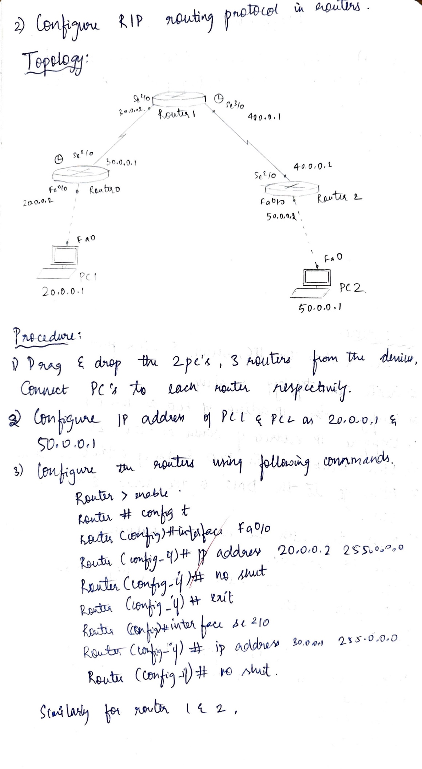

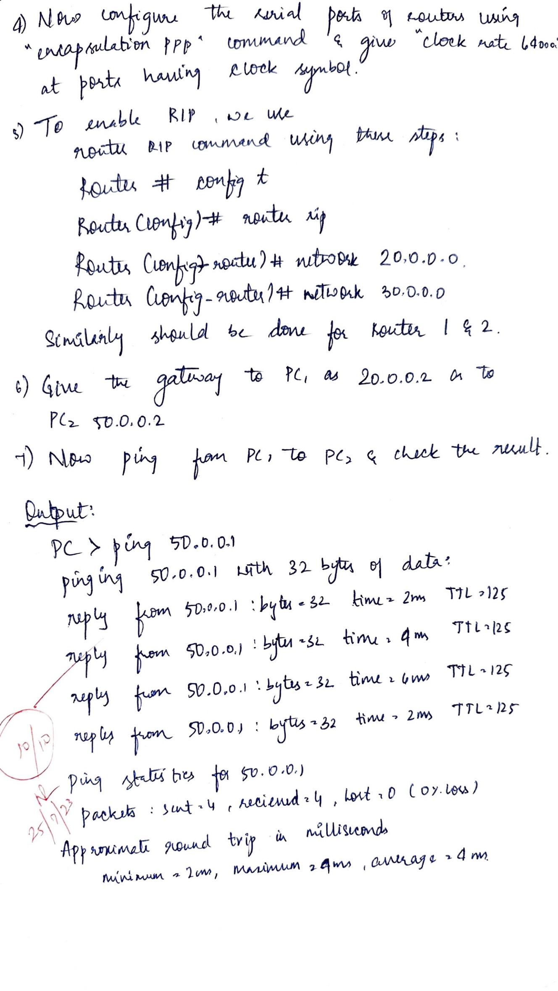

**Topology:**

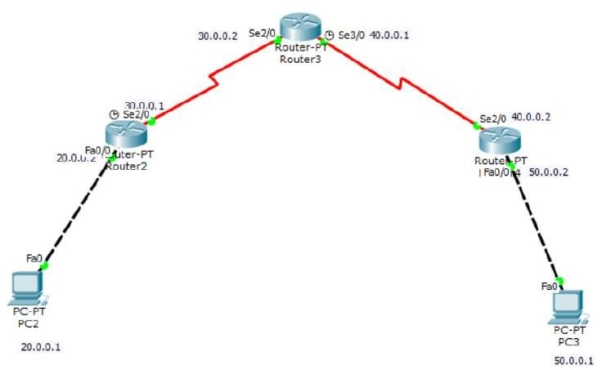

**Output:**

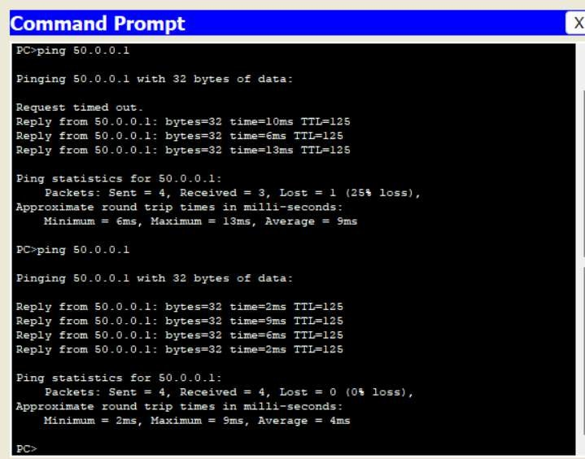

**Program-6**

**Configure OSPF routing protocol**

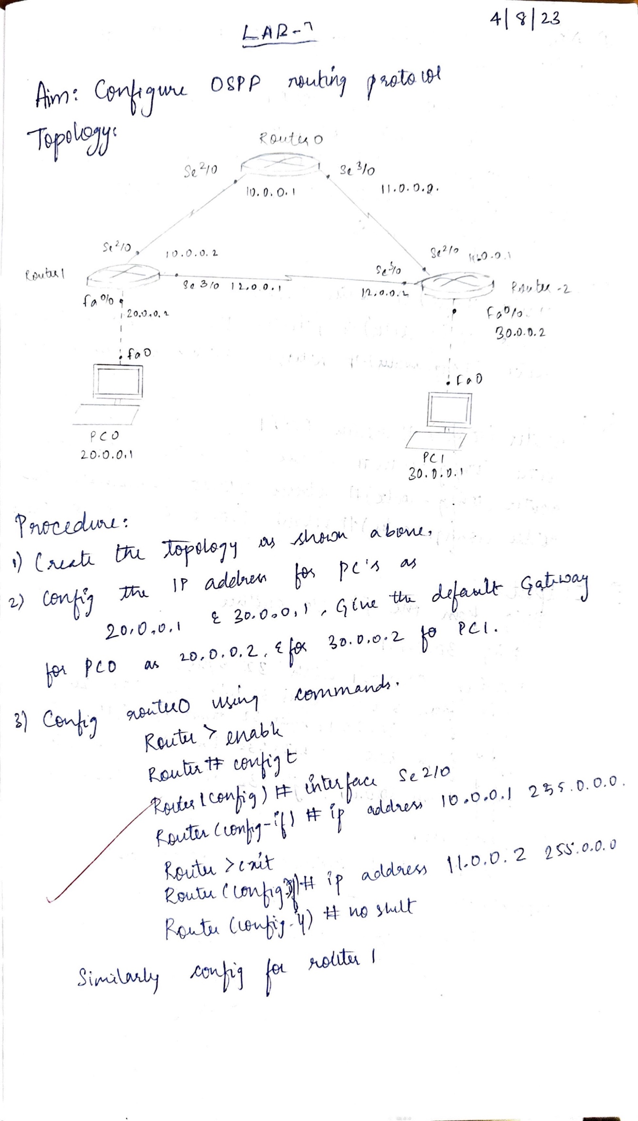

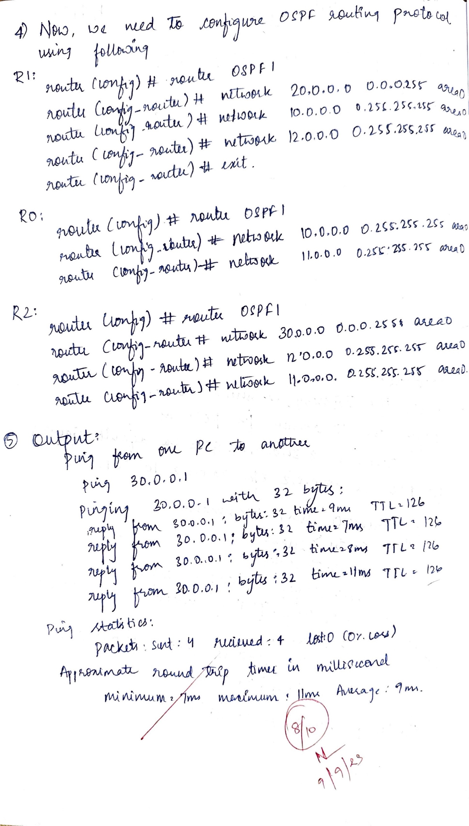

**Topology:**

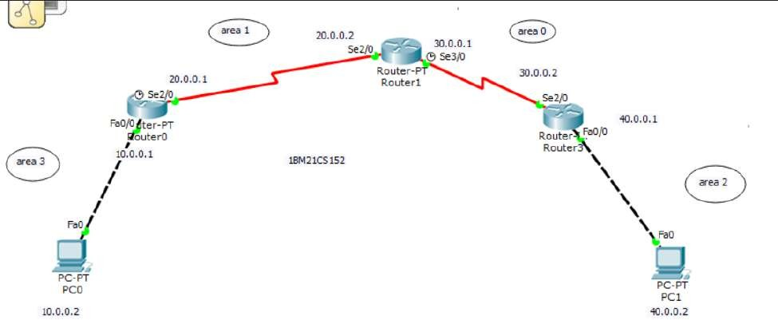

PROGRAM -7

Demonstrate the TTL/ Life of a Packet

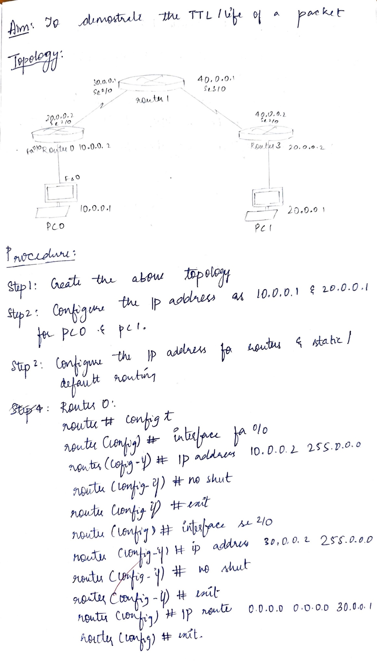

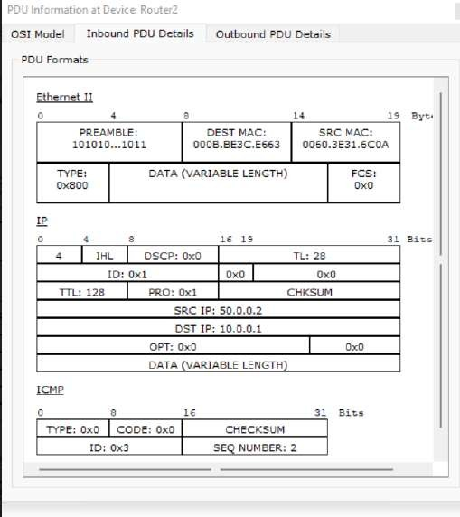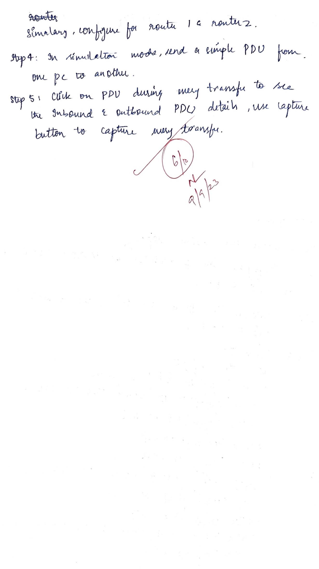

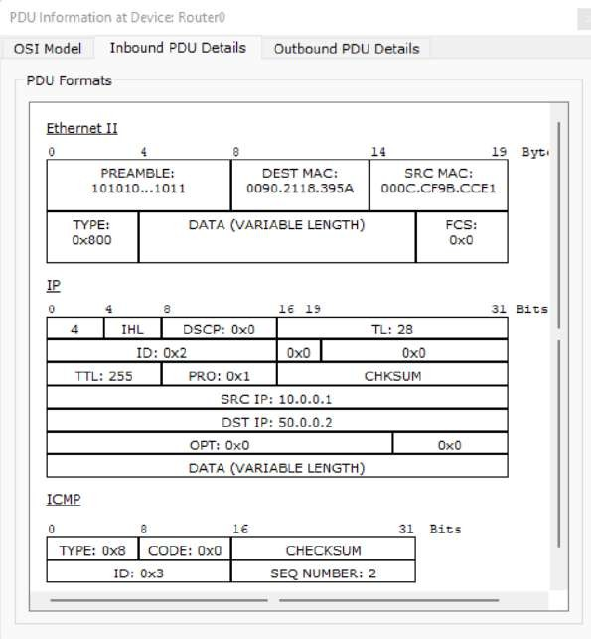

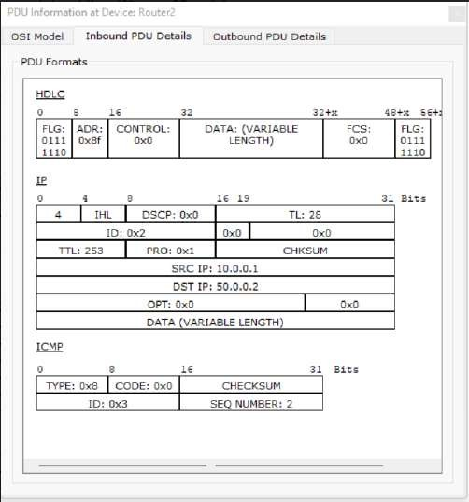

PROGRAM -8

Conﬁgure Web Server, DNS within a LAN.

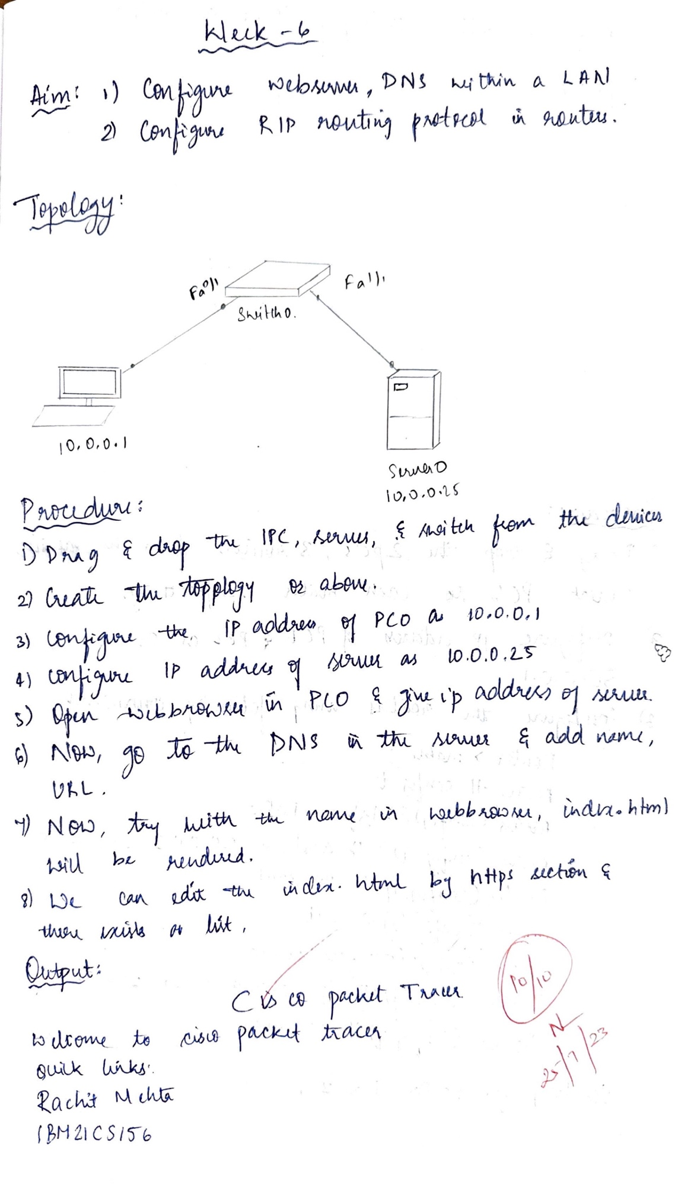

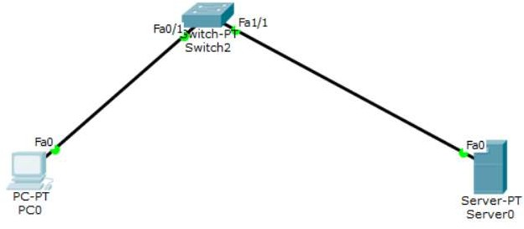

PROGRAM -9

To construct simple LAN and understand the concept and operation of Address Resolution Protocol (ARP)

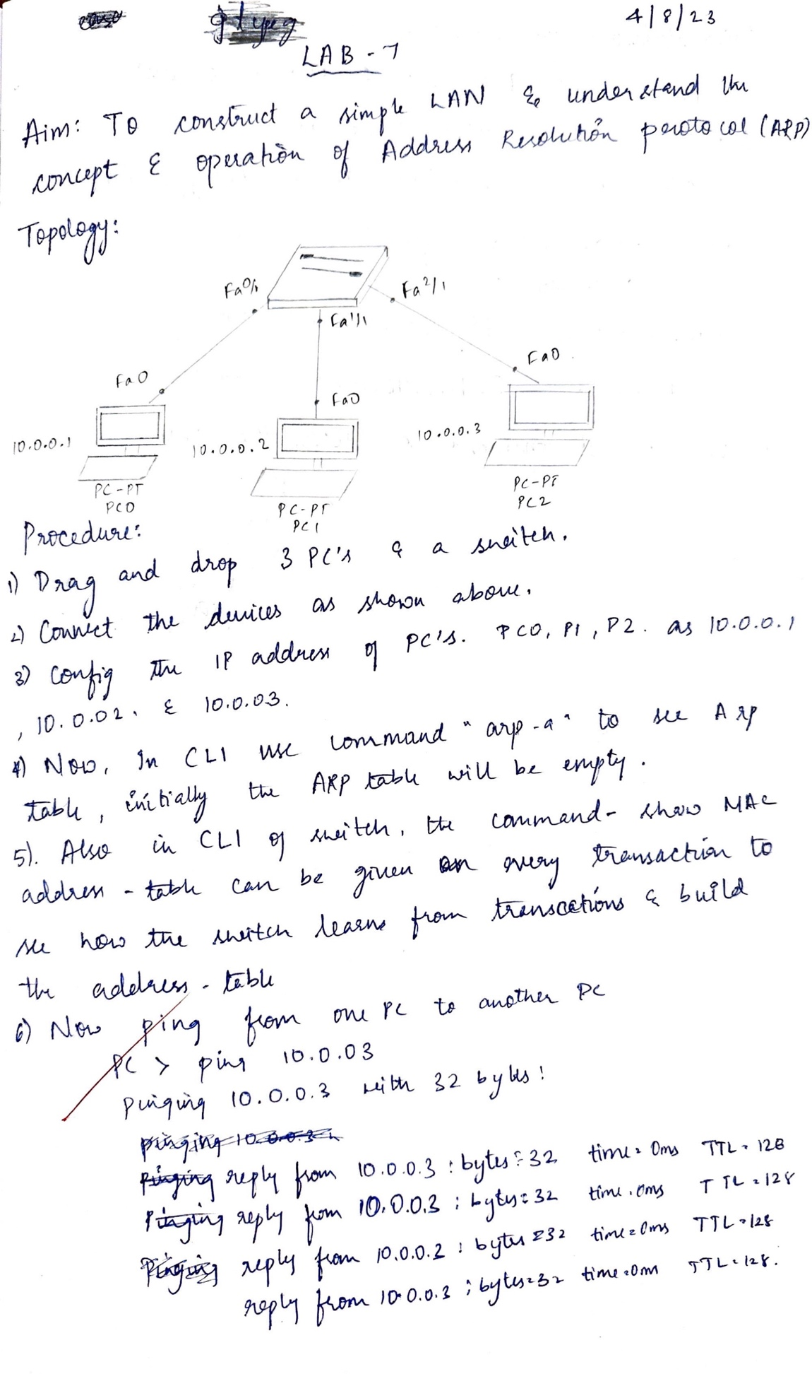

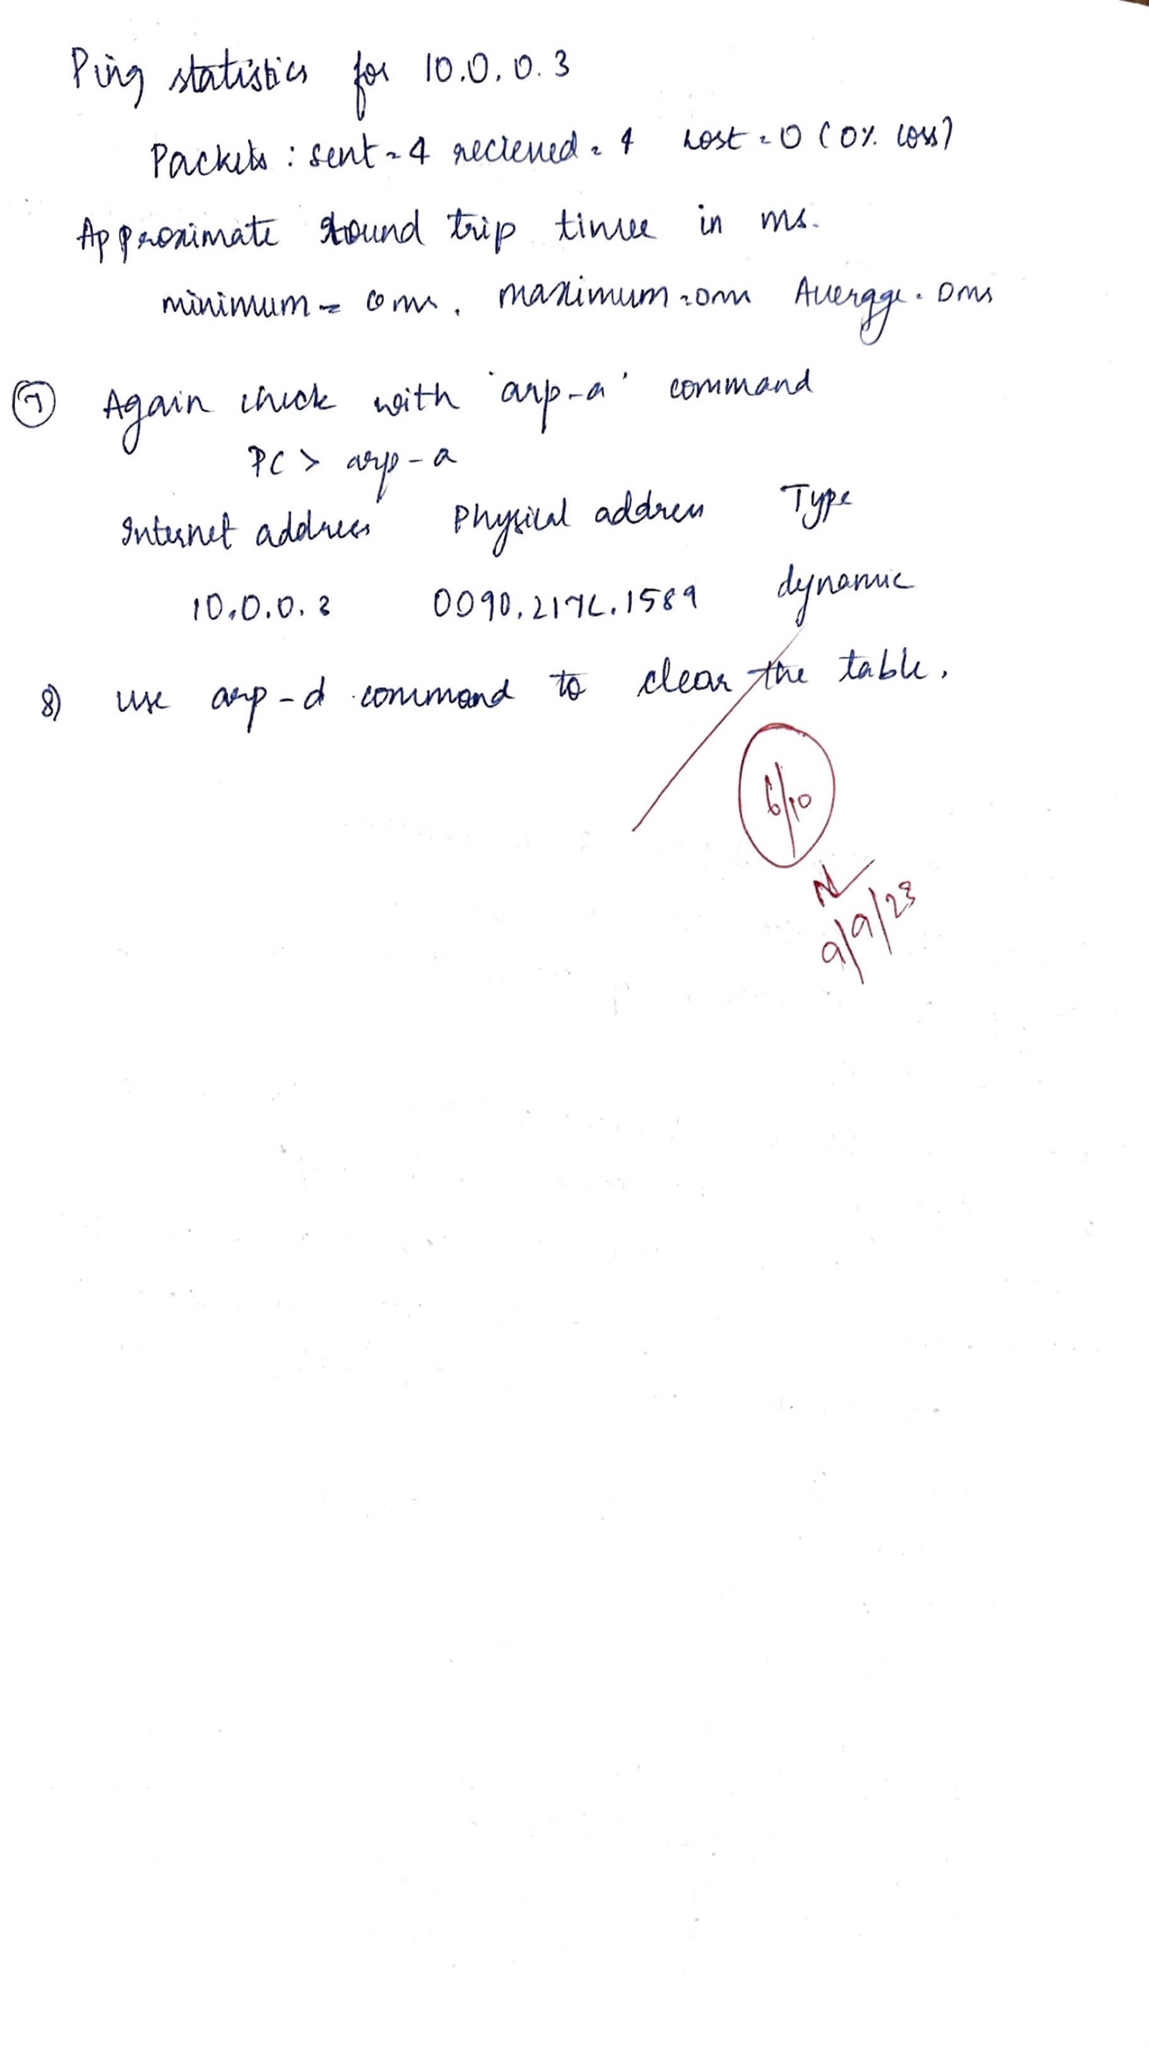  
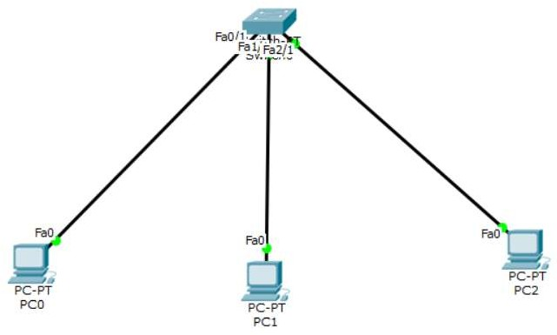

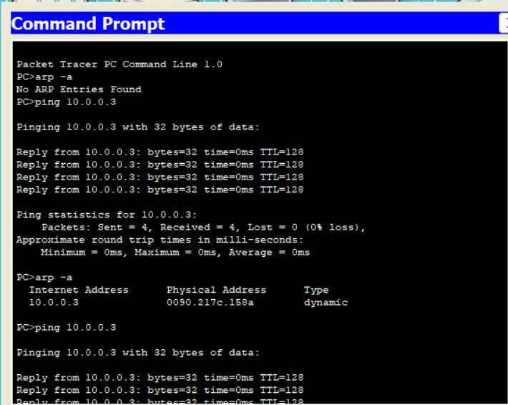Output:

PROGRAM -10

To understand the operation of TELNET by accessing the router in server room from a PC in IT oﬃce.

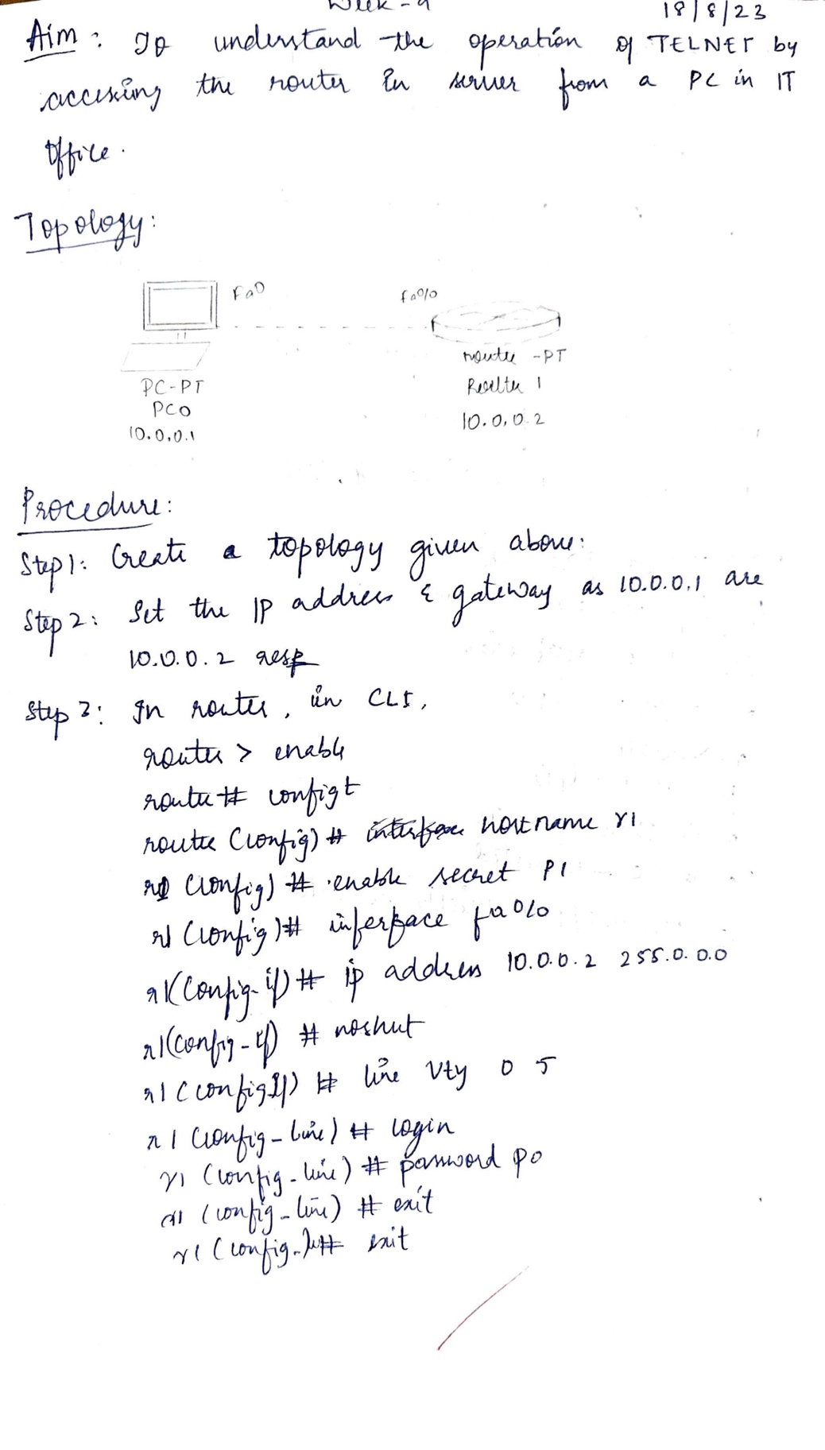

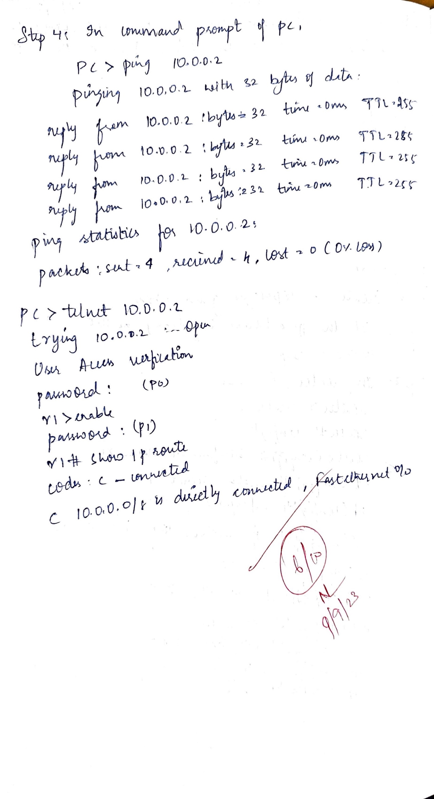

Topology:

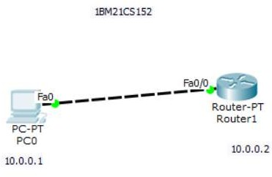

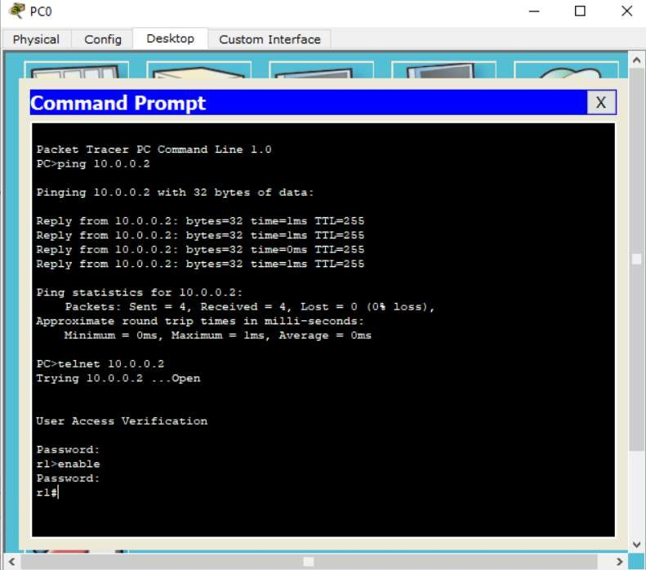Output:

PROGRAM -11

To construct a VLAN and make the PC’s communicate among a VLAN

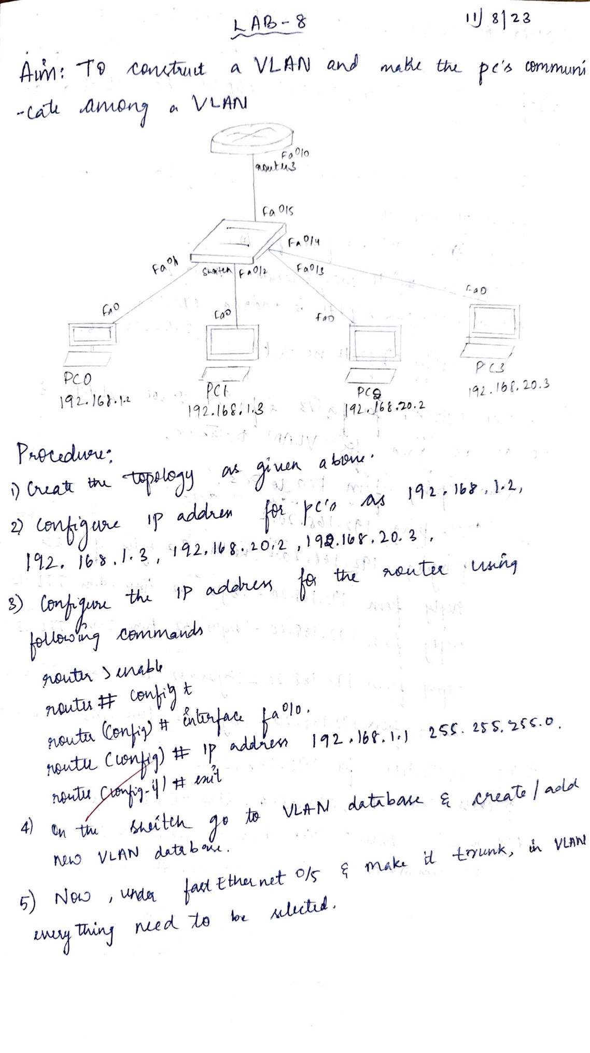

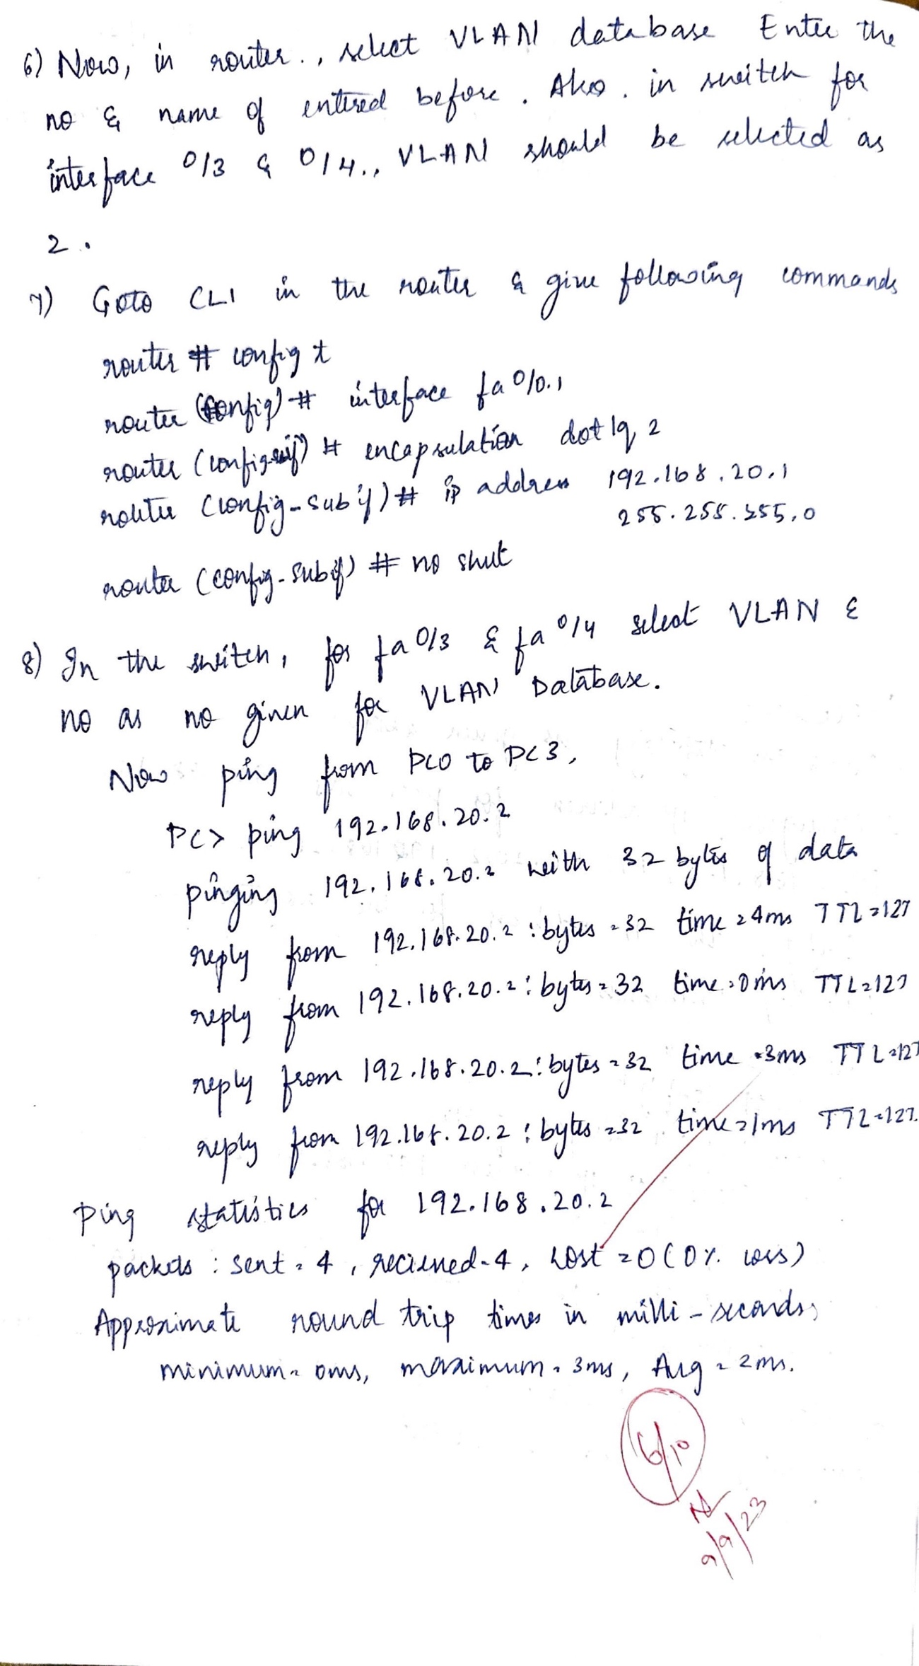

Topology:

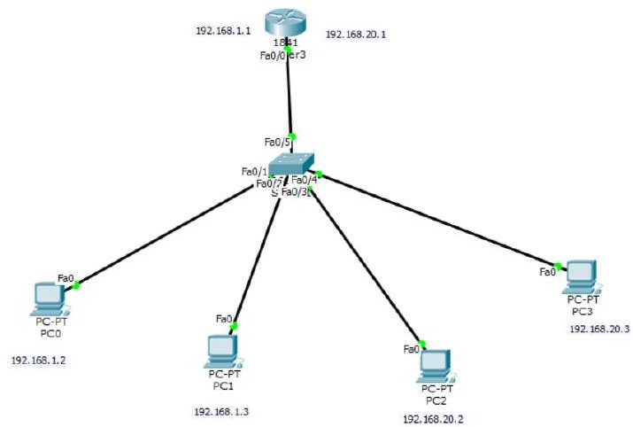

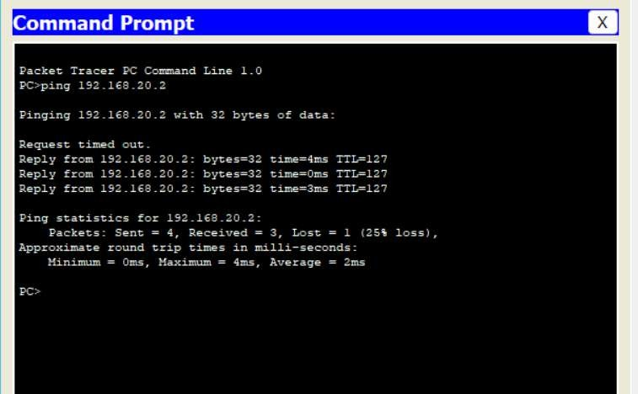Output:

# Program- 12

**To construct a WLAN and make the nodes communicate wirelessly**

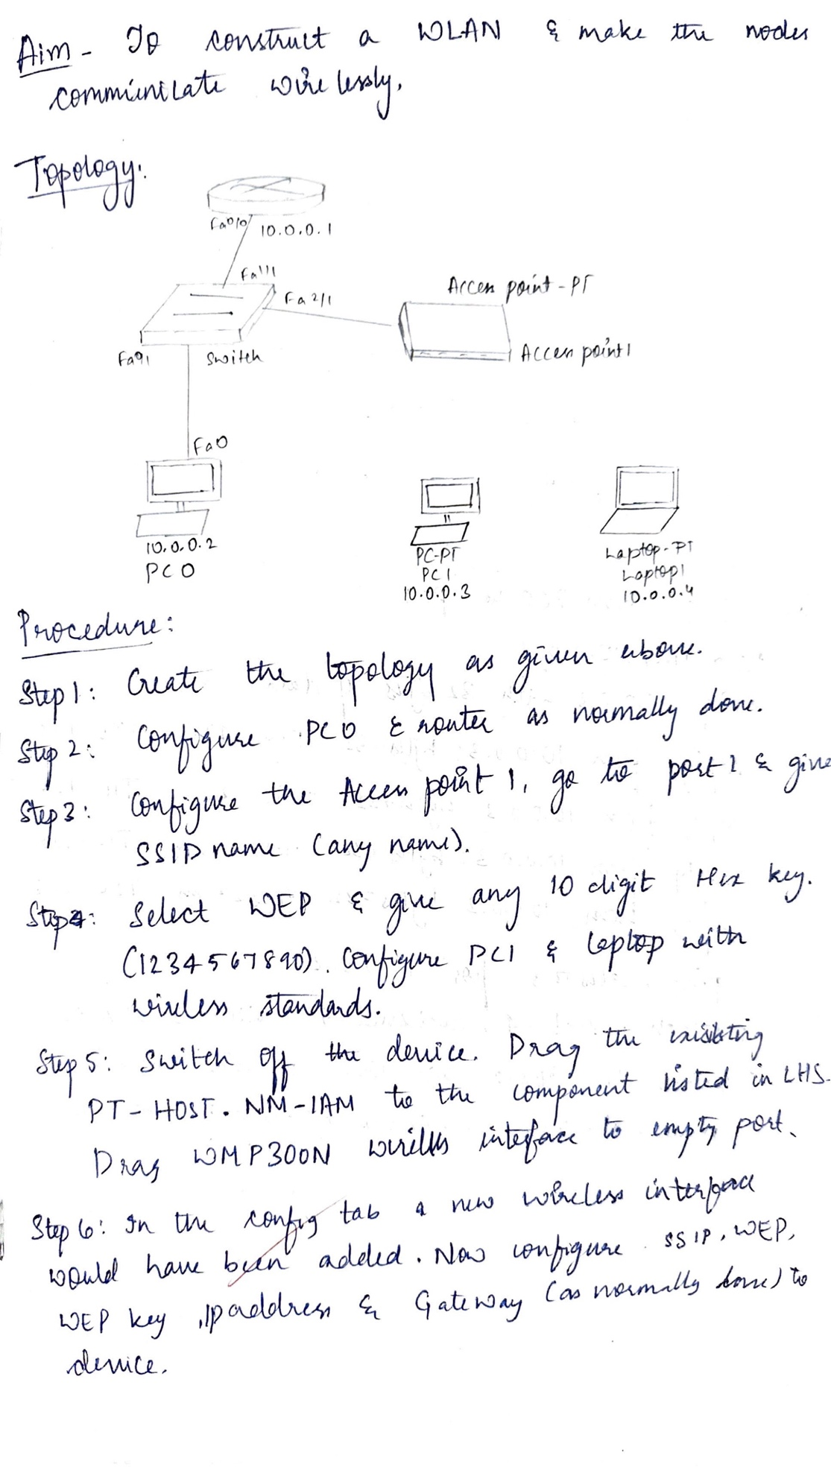

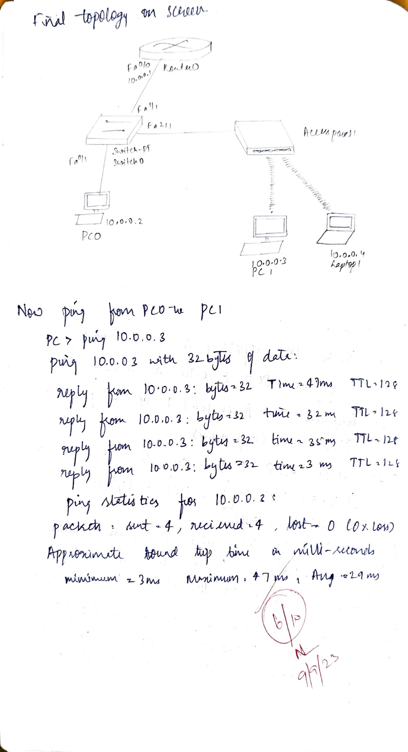

Topology:

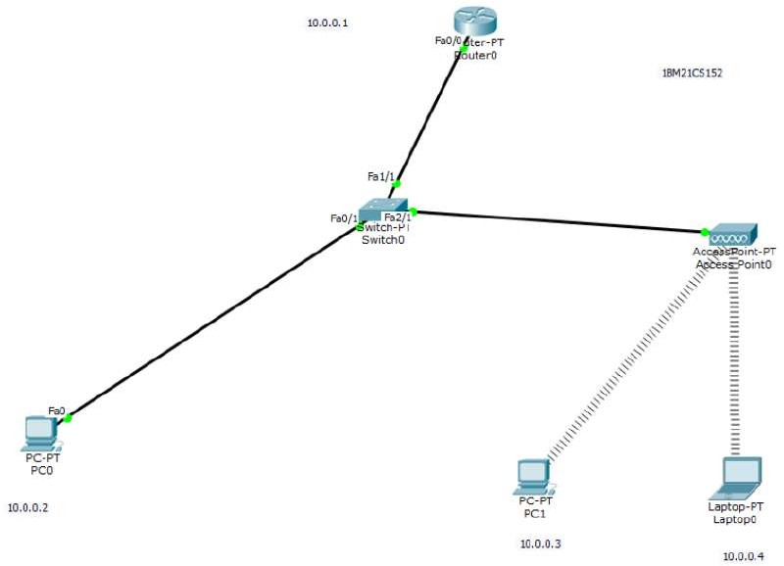

Output:

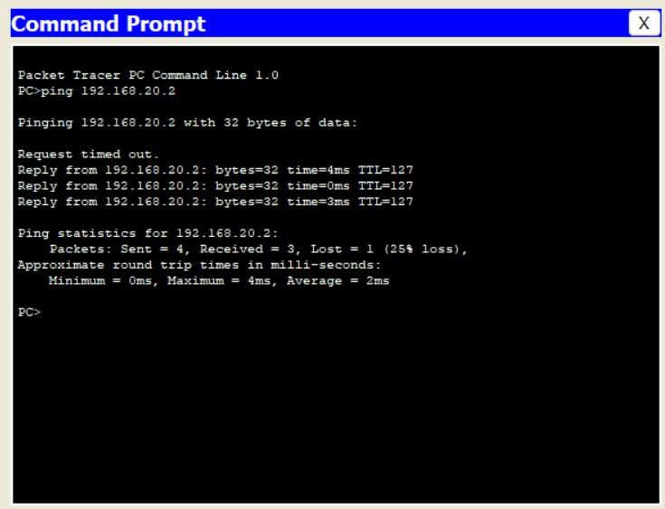

CYCLE-2

Write a program for error detecting code using CRC-CCITT(16 bits)

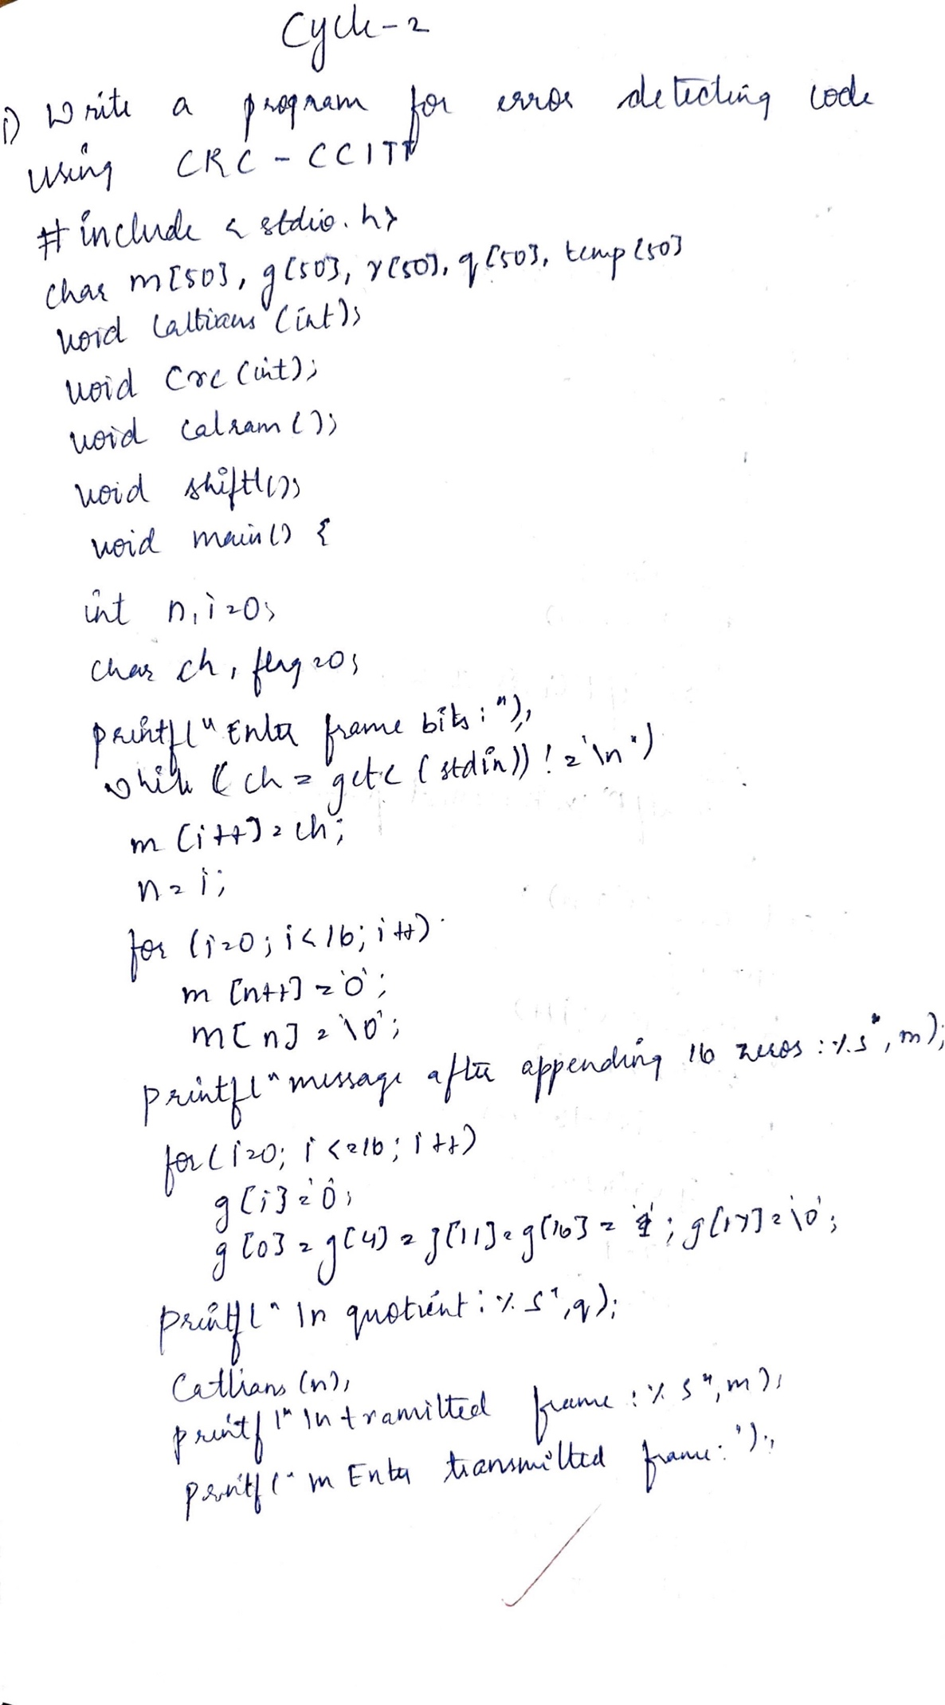

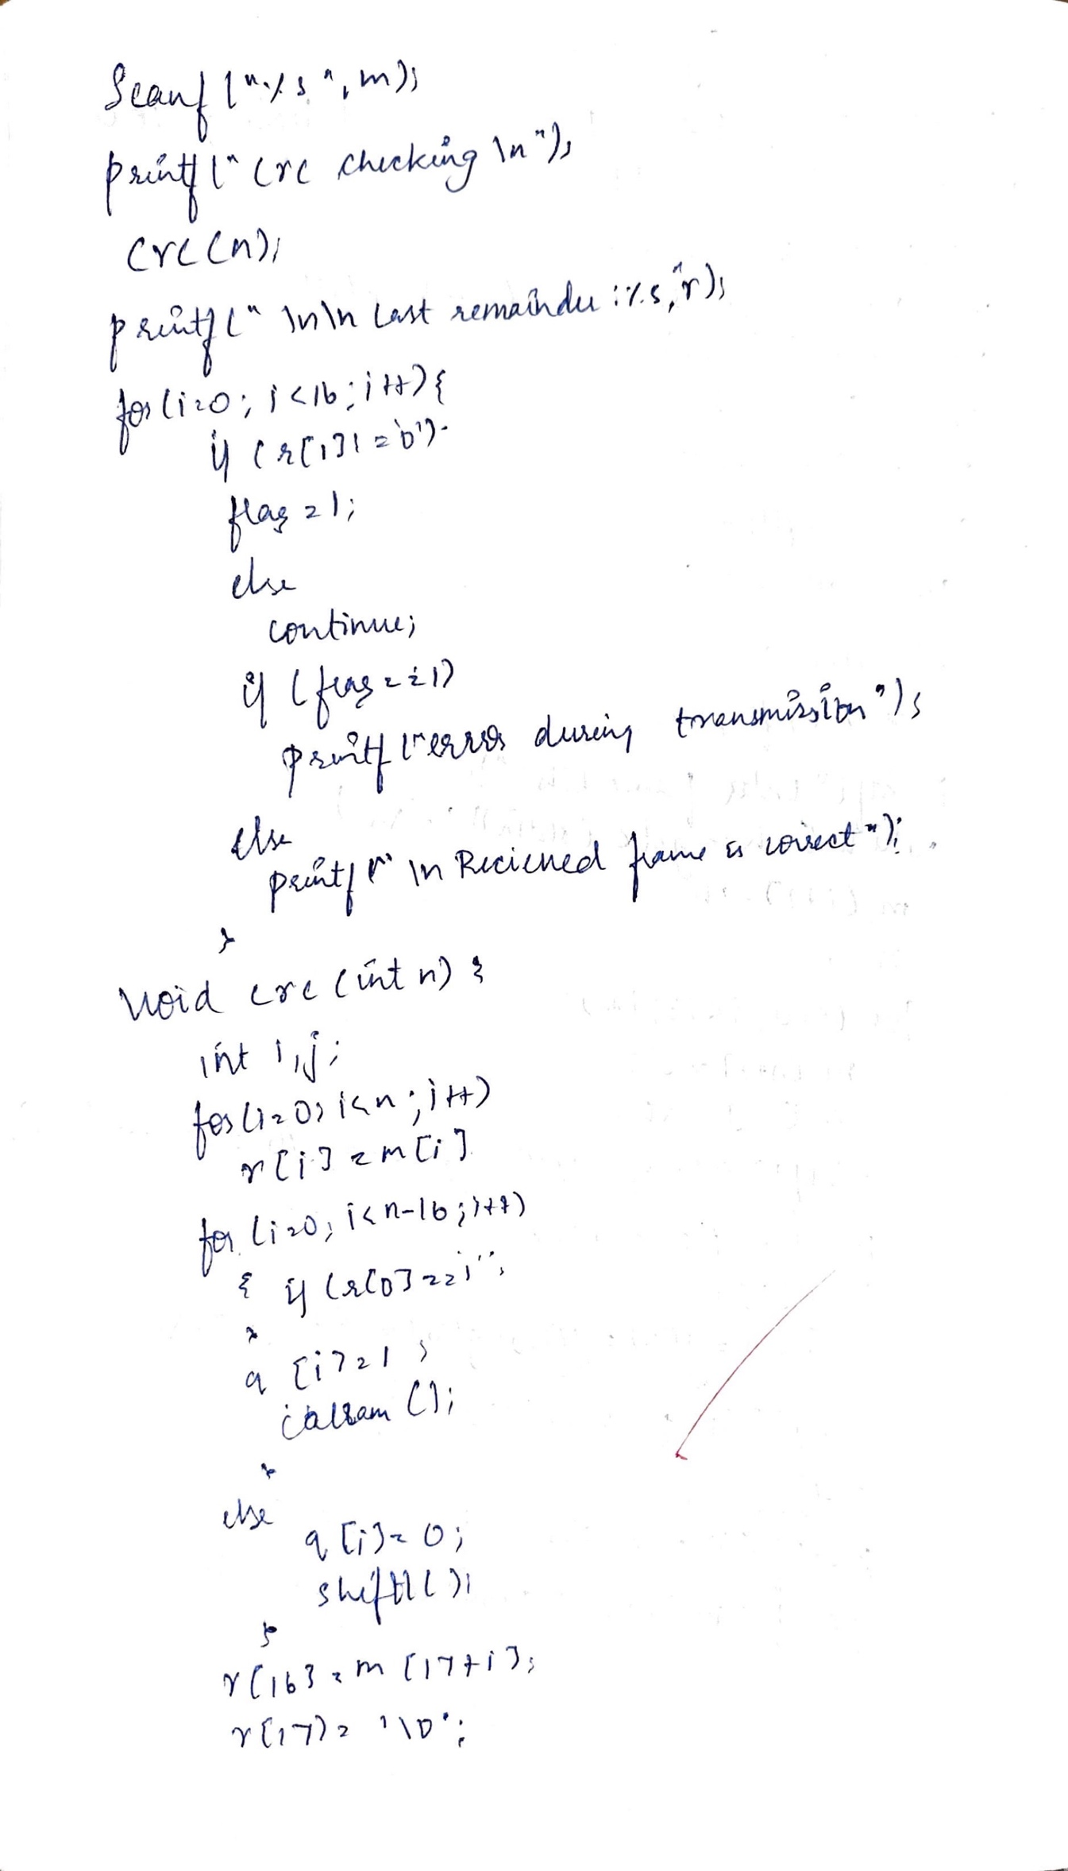

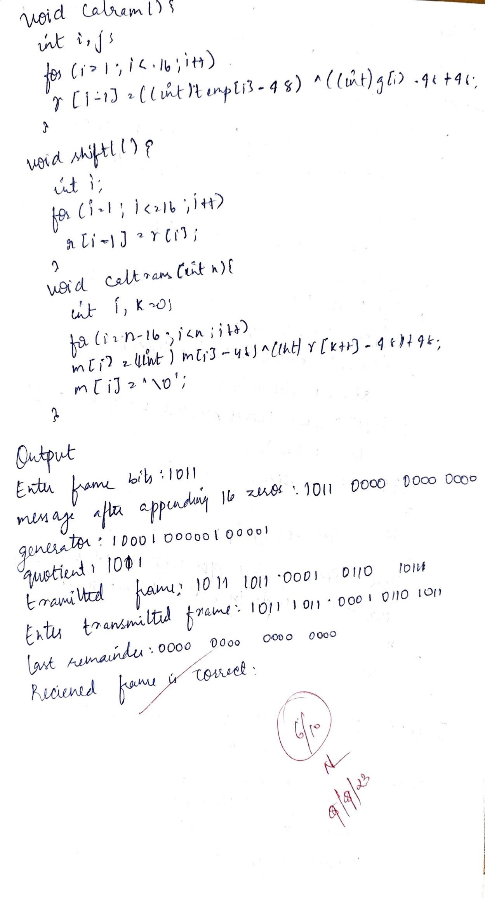

Output:

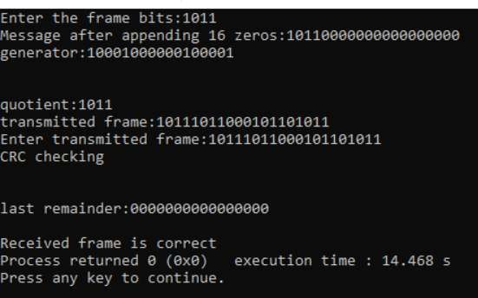

Write a program for congestion control using leaky bucket algorithm

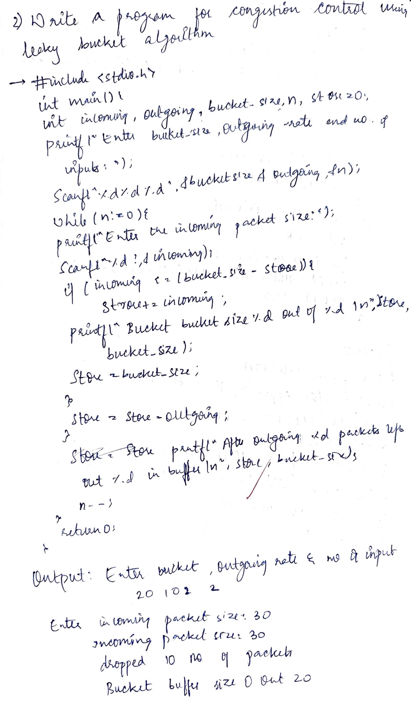

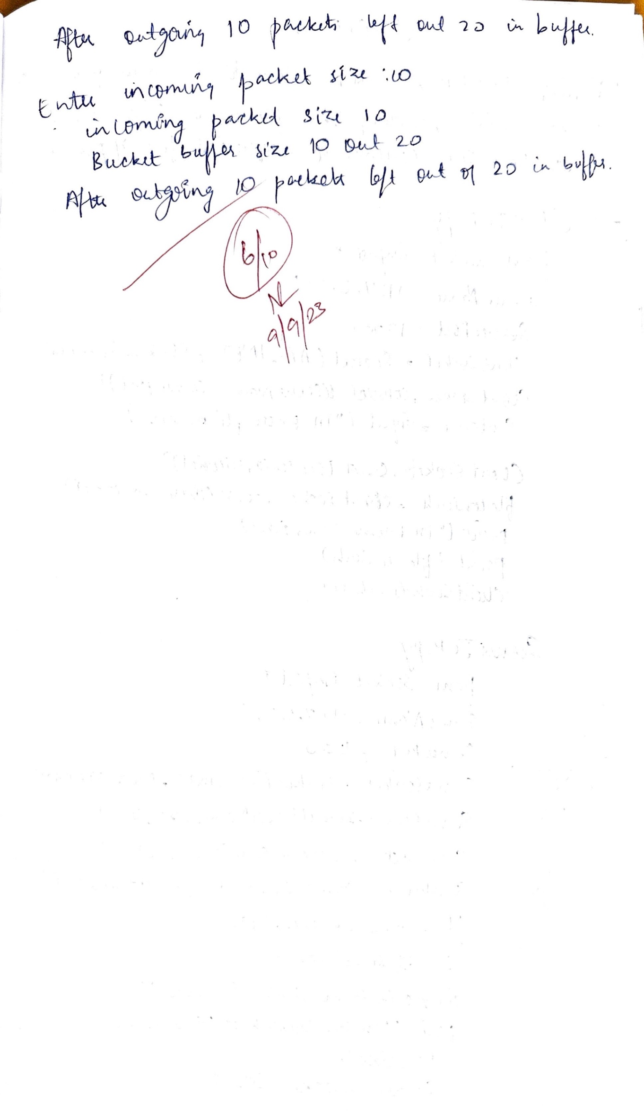

Output:

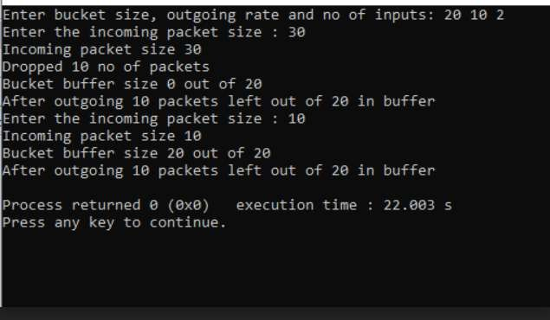

**Using TCP/IP sockets, write a client-server program to make client sending the ﬁle name and the server to send back the contents of the requested ﬁle if present.**

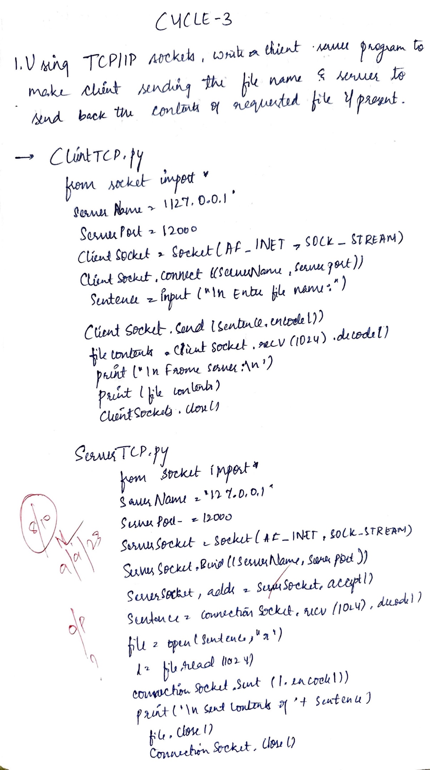

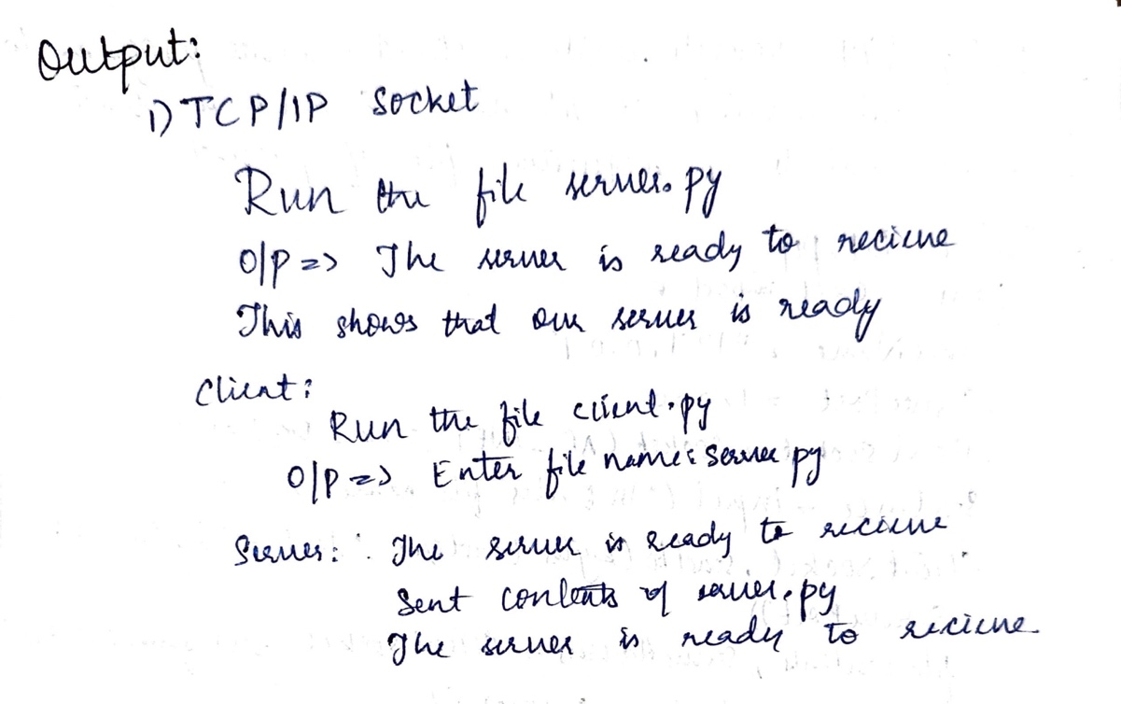

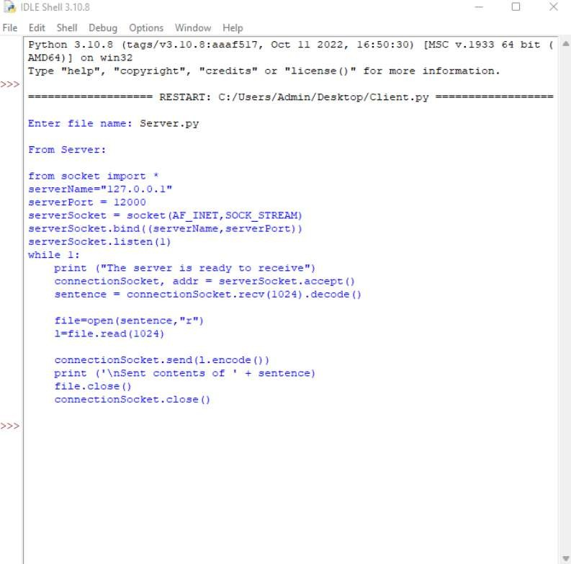

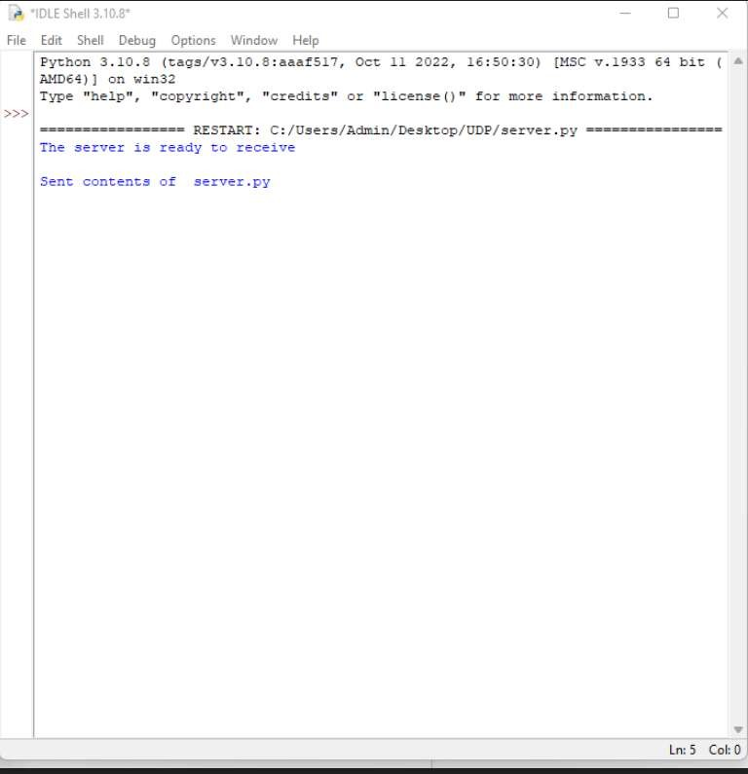

**Using UDP sockets, write a client-server program to make client sending the ﬁle name and the server to send back the contents of the requested ﬁle if present.**

